

Night Operations at
Truckee Tahoe Airport

Airport Community Advisory Team
January 13, 2015

Blank Page

Table of Contents
Table of Contents 3
Introduction 1
Preliminaries 1
Defining “Night” 1
Challenges of Flying in Darkness 2
Study Context 2
Operational Patterns and Trends at Truckee Tahoe 3
Recommendations 5
Conclusions 6
Appendix A: Data Methodology 8
Operations Data Capture History 8
Data Used for Night Ops 8
Appendix B: Operations, 11:00 p.m. - 6:00 a.m., 2011 - 2013 10
Tabular Data 10
Graphs 13
Appendix C: Night Operations Survey 16
Appendix D: Fleet Mix Changes 17
Appendix E: Operations During Darkness, Selected Periods of 2013-2014 18
Tabular Data 18
July-August 2013 18
December 2013 - January 2014 20
Graphs 24
Appendix F: TTAD Board of Directors, Agenda Item, Curfew/Night Operations Restrictions 27
Background 27
Options 27
Analysis 27
Appendix G: 2006 ACAT Part 161 Study Recommendation 29
Background 29
FAA Guidelines & Criteria 29
Other Airports 30
Truckee Tahoe Airport Conditions and Facts 33
Options for Action 34
Conclusion & Recommendation 34
Appendix H: United States Naval Observatory Astronomical Tables, Truckee, California (2014) 36
Sunrise and Sunset 36
Civil Twilight 37
Appendix I: Federal Aviation Regulations § 61.57 (Recent flight experience: Pilot in command) 38
(a) General experience. 38
(b) Night takeoff and landing experience. 38
(c) Instrument experience. 39
(d) Instrument proficiency check. 43
(e) Exceptions. 43
(f) Night vision goggle operating experience. 45
(g) Night vision goggle proficiency check. 46
Bibliography 48

Introduction
This paper attempts to assess the scale of night operations at the Truckee Tahoe Airport, to project what future rates may be, and to suggest proportionate and effective options for managing growth. For many years, Truckee Tahoe Airport has used operational data, but there has never been a comprehensive examination specific to night operations. This paper therefore brings together
- an analysis of a broad set of data on curfew non-compliance from 2011 through 2013;
- an analysis of data on activity after dark during peak winter and summer season in 2013-2014
- Master Plan projections for activity at the Airport in the future;
- industry literature; and
- prior studies and memoranda prepared for the Board and ACAT on night operations and related topics.
The methodology for collecting data is described in more detail in appendix A. For economic analyses and projections, the study relies on work performed for the Master Plan, as encapsulated in the Master Plan’s activity projections. More detailed study could be done, with outside assistance, in a second phase of the project if desired.
Based upon the work above, the paper concludes that night operations at the airport are few but increasing, and that the increase is likely to continue. It therefore recommends that the Board take action now, in the form of measures a. – g. listed on page 6.

Preliminaries

Defining “Night”
The word “night” can give rise to confusion. Aviators use it for periods with certain natural light conditions; laypeople tend to think in terms of the clock and cultural norms—neither of which has a fixed relation to light conditions. Since this study considers, among other things, how aircraft capabilities for flying during aviation “night” may affect operations patterns during what district residents consider to be “night,” more precise language is essential.
For clarity, then, this paper reserves the term “night” for the period between 10:00 p.m. and 7:00 a.m., that is, to a period when residents generally expect quiet. In doing so, it maintains consistency with the usage of “night” in the District’s surveys of residents, as well as with FAA and State of California metrics for noise evaluation and local noise standards. The time in between the end of aviation daylight conditions in the evening and the beginning of aviation daylight conditions in the morning as defined in the Federal Aviation Regulations will be referred to as “darkness.”

Challenges of Flying in Darkness
It has been estimated that “not quite 5% of the flying takes place” at night with “nearly 30% of the fatalities and an additional 15% of the non-fatal accidents occurring at night.” Also “Ten-times as many accidents occurring on dark nights as with moon light.” Per a 2005 AVWeb article “almost every night or weather accident occurred in mountainous terrain” and “In the 2003 Nall report, 21.6% of fatal accidents (US wide) occurred at night vs. the Bay Area, where fully 43% of fatal accidents occurred at night.” While the focus of the referenced article concentrates on the Bay Area, it seems logical to state that we host many of the same aviators who struggle in that environment in our even more challenging environment.

Study Context
Nighttime aircraft operations disturb surrounding communities more than similar operations during the day. The FAA’s prescribed method for calculating an airport’s noise impact penalizes operations between 10:00 p.m. and 7:00 a.m. by 10 decibels. According to the FAA, operations during this period contribute heavily to an airport’s overall noise profile.
Moreover, although the absolute number of night operations at Truckee is not large now, district residents are concerned about an increase. Both 2013 Godbe survey and the workshops conducted for the Master Plan Update show that a large majority supports a curfew between 10:00 pm and 7:00 am. Master Plan workshop participants, who had an opportunity to rank the importance of various noise abatement issues, place nighttime operations and a curfew among their top priorities.
The Airport currently seeks to reduce night operations through voluntary curfews. It has two curfew periods. All aircraft are asked to comply with a core 11 p.m. – 6:00 a.m. curfew, and hangar tenants at Truckee Tahoe can receive discounts for compliance with that curfew through participation in the Fly Quiet program. Hangar tenants can also receive additional discounts through Fly Quiet if they observe an expanded curfew of 10:30 p.m. – 6:30 a.m. These programs are publicized on the Airport’s website and the great majority of hangar tenants participate in Fly Quiet.
The Airport’s business hours, although based on commercial rather than noise considerations, may also be having an incidental effect on the amount of night activity at Truckee Tahoe. For cost and operational reasons, the Airport provides fueling, tows and other aviation services only between 7 a.m. and 7 p.m. Buildings are secured for the evening at 9:30 p.m. and re-open at 7 a.m. While the airfield remains accessible and partially lit at night, it is possible that some travellers are electing to arrive or depart during normal Airport hours instead for the added safety, comfort and convenience.

Operational Patterns and Trends at Truckee Tahoe
Traditionally, the Airport has relied on the surrounding terrain and on operator specifications (ops specs) to constrain night operations. And to date annual operations at night have numbered in the dozens. An examination of operational data, however, suggests that circumstances may be more complex and less stable than previously assumed.
Curfew violating operations, for example, show a significant amount of growth. In 2013, 39 non-medical operations took place from 11:00 pm to 6:00 am. This number represents an increase of 39.3% over the prior year. 2012 also saw growth as compared to 2011, albeit at a more modest 12.0%. For comparison, overall operations increased year on year by only 0.48% in 2013 and 3.6% in 2012. Night operations are becoming a larger proportion of activity at the Airport.
One reason for the greater rate of increase in activity at night, as compared to the general growth in operations, seems to lie in the changing character of the fleet mix at Truckee Tahoe, a phenomenon noted in the Master Plan. The great majority of operations disregarding the curfew are by transient, not based, aircraft, and this is a group projected to grow over the course of the next 20 years. Jet and turboprop aircraft are also increasing, suggesting a shift toward more business-type operations with staff pilots. These operations seem likely to prioritize passenger convenience over Airport noise sensitivity requests. When asked during an informal survey, charter, corporate and fractional operators confirmed that, with one significant exception discussed below, they would (and do) operate at Truckee-Tahoe at whatever hour a client wishes. In addition, business operations reposition aircraft much more frequently than individual operators, leading to multiple operations for a single travel event. This is a very different mode of activity from the locally-based, personal aircraft the Airport currently targets in its noise abatement incentive programs.
The spread of more advanced IFR technology likely contributes to an increasing growth rate as well. To date, the prevailing view has been that the terrain surrounding the Airport is a strong constraint on operations after dark. But although there are relatively few operations during the night, Truckee-Tahoe does have hundreds of arrivals and departures in darkness. Most of these are either turboprops or jets, which typically carry more advanced avionics suites, but a substantial number of piston aircraft also fly in darkness. The pattern of operations during winter peak season in 2013-2014 illustrates the phenomenon well: darkness fell before 6:00 p.m. but arrivals and departures by all kinds of aircraft remained lively until around 8:00 p.m. One new technology that facilitates flying in darkness, synthetic vision, is already common and seems likely to become standard in the coming years. While still an optional feature on even high-end avionics suites, most business aircraft built or retrofitted since 2011 or 2012 carry it. Pilots who lack synthetic vision on their aircraft but consider it critical to flying into Truckee at night have been able to get mobile versions quickly and inexpensively since 2011. Other, perhaps even more significant technologies include advanced navigational procedures and aids not yet present at Truckee Tahoe. The advent of Next Gen satellite navigation technologies is advancing quickly nationwide. As one example of the impact of Next Gen technologies, development of an RNP procedure at Juneau allowed a commercial carrier to begin operating in instrument conditions there despite terrain. And a major operator at Truckee-Tahoe says that it would operate in darkness here if the there were vertical guidance. The bulk of the impact from technological change may still be coming.
Aside from growth, the data reveals another interesting pattern in night operations: concentration. There is a seasonal surge in late night (that is, early morning) operations every summer. Operations between 3:00 a.m. and 6:00 a.m. form a steady 45% of the annual operations disregarding the core curfew, yet they are almost entirely confined to the period from June to September. As a result, summer nights are significantly noisier than winter ones. Night operations are also concentrated spatially, clustering on Runway 29. They are therefore likely to have a disproportionately large effect on certain neighborhoods. As a result, the perceived noise may be more intense than annualized night operation rates would suggest.
Should these patterns remain in place, the Airport can expect night operations to become more prominent. They seem likely to grow at least as fast as operations at the Airport, and perhaps faster if the fleet mix continues to shift toward business-type flights and if Next Gen technologies make night operations safer. Moreover, the populations most associated with the growth—transient and business operators, and their passengers—are not covered by current Airport incentive programs, nor are passengers targeted in current outreach programs.

Recommendations
Because the volume and character of night operations is changing, the Board should consider adjusting the Airport’s approach. Any discussion of measures relating to noise abatement must consider the regulatory framework, on which outside legal counsel Peter Kirsch briefed ACAT in 2014. Mandatory rules must meet the formidable requirements of Part 161 of the Federal Aviation Regulations. In 2006, ACAT studied whether the Airport should undertake the effort, and concluded that the cost would be very high, while the likelihood of success was very low. Since that study, the regulatory landscape has remained largely the same and no airport has succeeded in leaping the regulatory hurdle, although several have tried. ACAT therefore did not consider measures to restrict access to the Airport. A mandatory curfew is not proposed. Instead, ACAT recommends that the Airport refine and supplement its current voluntary programs and outreach efforts such that they reach all populations by implementing the following measures.
- Enhance Unicom protocols to require outreach to all potential night operations of which the Airport becomes aware, such outreach to request compliance with curfew hours and to inform pilots, operators and/or passengers of the safety concerns, heightened noise sensitivity, and limited services available during night hours.
- Publicly thank users who change their flight plan to avoid operating at night.
- Install signage in the terminal, at gates, and in other high-traffic areas to communicate directly with passengers, as well as pilots and operators, on noise sensitivity and quiet hours.
- Create a formal District Policy requiring assessment of the potential impact on night operations of contemplated changes or additions to airport services, facilities, and/or navigational aids or procedures, and requiring Board review and approval of the night operations impact before the Airport commits itself to a change or addition.
- Unify Fly Quiet program curfew hours and general voluntary curfew hours so that the Airport has a single voluntary curfew period, for consistent communications and ease of administration.
- Conform curfew hours to night hours (10 p.m. to 7 a.m.).
- Develop a financial incentive program for curfew-compliant transient operators.
These measures can be implemented separately or in concert. Most are low-cost.

Conclusions
Night-time activity and related curfew non-compliance are increasing at Truckee Tahoe. Transient and business-type operations, which are more likely to fly during curfew hours, represent a growing portion of activity at the Airport. Darkness and terrain no longer bar operations as firmly as once they did, and new navigational technologies may make night operations here still less daunting. There are a number of non-restrictive measures available to the Airport that might help offset these trends, including supplementing current pilot incentives and reaching out to passengers, who often have a strong influence on operation times. These measures should be implemented at this time, and night operation rates should be reviewed twelve to twenty-four months after implementation to determine whether further action is appropriate.

Appendix A: Data Methodology

Operations Data Capture History
Capturing operations data at Truckee Tahoe Airport has evolved significantly over the past ten years. Early on, operational estimates were based on sale of fuel, overnight parking, and associated goods and services sold. While it is a broad approach, this methodology continues to be used for reference and is a valuable guideline for estimation purposes. Software for personnel to manually count operations was used for several years in mid-2000 where the operator would physically count planes. The human factors and number of distractions in Unicom made this type of data gathering questionable in terms of accuracy.
In 2007, the District procured an automated system to capture operations. The WASP system is a group of four cameras that capture aircraft taxiing to or from a runway end. The supporting software analyzes tail numbers and assigns the type and time of operation. This system has been an excellent tool for capturing departures that taxi past the cameras. Quarterly and annual operational counts are based on the number of departures captured. An operation is defined as an arrival or departure. Departures are then doubled for operational reporting purposes. Estimations for transient helicopter, touch and go, and glider activity have supplemented the WASP system, since they are not captured by the cameras.
While the District has owned a flight-tracking system for several years, the use of WAM (wide-area multi-lateration) data has not been used for operations reporting. Until recently, the fusion of the camera data and MLAT (multi-lateration) data has not been available. Thus, all operations data has been estimation based on observations, sales, and the tools available during the reporting periods.

Data Used for Night Ops
The Night Ops subcommittee decided to use data from all available resources for the Night Ops Study. Those resources include the Complaint Database, the WASP system, and the MLAT system. The benefits include detailed observations of arrivals and overflights, which are not available when extrapolating data from the WASP system alone. The use of all data sources paints a significantly more accurate depiction of Night Operations at KTRK since it utilizes all available resources to accurately determine the time and type of operation.
Staff queried each distinct data repository for all times periods studied in the report and corrected the final product to remove any duplicates and ensure that all operations reported are accurate. The compilation of data sets are represented within the Night Ops document and may not synch entirely with previously reported data sets from Board Meetings or the Master Plan figures. Since the task of the subcommittee was to look granularly at night operations, the most detailed data views were chosen for reporting purposes.
Each operation reported within this document can be verified. No estimations were used for observations.

Appendix B: Operations, 11:00 p.m. - 6:00 a.m., 2011 - 2013

Tabular Data
Date | Day (Local) | Time (Local) | Arrive/  Depart | RWY | Type | Aircraft | Local/ Transient | Comp-laint | Comment | Counts
2013
1/1/2013 | Tuesday | 11:09 PM | A | 29 | J | Cessna Citation 560 | Transient |  |  | 1
1/27/2013 | Sunday | 11:24 PM | A | 20 | TP | Pilatus PC12 | Transient |  |  | 1
1/27/2013 | Sunday | 11:35 PM | D | 29 | TP | Pilatus PC12 | Transient |  |  | 1
3/28/2013 | Thursday | 11:25 PM | D | 29 | Unk | Unk | Unk |  |  | 1
4/2/2013 | Tuesday | 11:34 PM | A | 29 | Unk | Unk | Unk |  |  | 1
5/13/2013 | Monday | 11:06 PM | D | 11 | P | Cessna T206 | Transient |  |  | 1
5/15/2013 | Wednesday | 5:25 AM | D | 29 | P | Cessna T210 | Local | Y |  | 1
5/22/2013 | Wednesday | 11:18 PM | A | 29 | Unk | Unk | Unk |  |  | 1
5/31/2013 | Friday | 5:48 AM | D | 29 | P | Mooney M20K | Transient |  |  | 1
6/3/2013 | Monday | 11:01 PM | A | 20 | Unk | Unk | Unk |  |  | 1
6/5/2013 | Wednesday | 5:40 AM | D | 11 | Unk | Unk | Unk |  |  | 1
6/5/2013 | Wednesday | 11:05 PM | D | 29 | Unk | Unk | Unk |  |  | 1
6/5/2013 | Wednesday | 11:47 PM | D | 11 | Unk | Unk | Unk |  |  | 1
6/7/2013 | Friday | 1:43 AM | A | 11 | Unk | Unk | Unk |  |  | 1
6/8/2013 | Saturday | 11:24 PM | A | 29 | Unk | Unk | Unk |  |  | 1
6/10/2013 | Monday | 11:41 PM | A | 20 | Unk | Unk | Unk |  |  | 1
6/13/2013 | Thursday | 11:03 PM | A | 11 | Unk | Unk | Unk |  |  | 1
6/29/2013 | Saturday | 11:12 PM | A | 11 | TP | KA 200 | Transient |  | Medical | 1
6/30/2013 | Sunday | 1:47 AM | D | 2 | TP | KA 200 | Transient |  | Medical | 1
7/8/2013 | Monday | 5:47 AM | D | 11 | Unk | Unk | Unk |  |  | 1
7/10/2013 | Wednesday | 11:36 PM | A | 11 | P | Mooney M20K | Transient |  |  | 1
7/11/2013 | Thursday | 5:47 AM | D | 29 | P | Cessna 182 | Transient |  |  | 1
7/14/2013 | Sunday | 11:16 PM | A | 29 | P | Cessna T210 | Local |  |  | 1
7/15/2013 | Monday | 11:01 PM | D | 29 | J | Lear 35A | Transient | Y x2 | Medical | 1
7/29/2013 | Monday | 5:58 AM | D | 20 | Unk | Unk | Unk |  |  | 1
8/1/2013 | Thursday | 12:19 AM | A | 29 | TP | Pilatus PC12 | Transient |  |  | 1
8/2/2013 | Friday | 5:31 AM | D | 29 | Unk | Unk | Unk |  |  | 1
8/4/2013 | Sunday | 5:45 AM | D | 29 | Unk | Unk | Unk |  |  | 1
8/5/2013 | Monday | 4:16 AM | A | 11 | J | Cessna 750 | Transient |  |  | 1
8/5/2013 | Monday | 5:38 AM | D | 11 | J | Cessna 750 | Transient |  |  | 1
8/25/2013 | Sunday | 11:11 PM | D | 29 | J | Gulfstream G-IV | Transient |  |  | 1
8/27/2013 | Monday | 5:31 AM | A | 29 | J | Cessna 525B | Transient |  |  | 1
8/27/2013 | Monday | 6:00 AM | D | 29 | J | Cessna 525B | Transient | Y |  | 1
8/28/2013 | Wednesday | 5:33 AM | D | 29 | P | Diamond DA40 | Transient |  |  | 1
8/30/2013 | Friday | 5:03 AM | D | 11 | Unk | Unk | Unk |  |  | 1
8/30/2013 | Friday | 5:03 AM | A | 20 | P | Beech V35 | Transient |  |  | 1
9/14/2013 | Saturday | 5:38 AM | D | 2 | P | Beech V35 | Transient |  |  | 1
9/20/2013 | Friday | 11:27 PM | D | 20 | P | Cessna 340 | Transient |  |  | 1
9/27/2013 | Friday | 11:27 PM | A | 20 | Unk | Unk | Unk |  |  | 1
10/7/2013 | Monday | 1:34 AM | A | 29 | P | Cessna T210 | Local |  |  | 1
10/19/2013 | Saturday | 6:00 AM | D | 29 | P | Cessna 414 | Transient |  |  | 1
10/22/2013 | Tuesday | 12:25 AM | A | 11 | P | KA C90 | Transient |  |  | 1
 |  |  |  |  |  | 6 repeater ACFT | 2 Local | 4, 0 repeat |  | 42
2012
1/27/2012 | Friday | 10:56 PM | D | 20 | TP | Piper PA-31T | Transient |  | Medical | 1
4/17/2012 | Tuesday | 12:13 AM | D | 11 | Unk | Unk | Unk |  |  | 1
4/20/2012 | Friday | 11:59 PM | A | 29 | P | Cessna T210 | Local |  |  | 1
4/28/2012 | Saturday | 1:27 AM | D | Unk | Unk | Unk | Unk |  |  | 1
5/9/2012 | Wednesday | 12:40 AM | D | 29 | H | Eurocopter A-Star | Transient |  | Medical | 1
5/14/2012 | Monday | 5:39 AM | D | 2 | Unk | Unk | Unk |  |  | 1
5/22/2012 | Tuesday | 11:11 PM | A | 20 | H | Eurocopter A-Star | Transient |  | Medical | 1
5/22/2012 | Tuesday | 11:29 PM | D | 20 | H | Eurocopter A-Star | Transient |  | Medical | 1
5/29/2012 | Tuesday | 12:12 AM | D | 11 | Unk | Unk | Unk |  |  | 1
6/4/2012 | Monday | 12:10 AM | A | 29 | H | Eurocopter EC130 | Transient |  | Medical | 1
6/4/2012 | Monday | 5:36 AM | D | 20 | Unk | Unk | Unk |  |  | 1
6/8/2012 | Friday | 11:23 PM | A | 20 | Unk | Unk | Unk |  |  | 1
6/15/2012 | Friday | 5:12 AM | D | 11 | TP | KA200 | Transient |  |  | 1
6/21/2012 | Thursday | 5:33 AM | D | 29 | P | Cessna P210 | Transient |  |  | 1
6/25/2012 | Monday | 12:11 AM | A | 20 | Unk | Unk | Unk |  |  | 1
6/28/2012 | Thursday | 5:59 AM | D | 29 | TP | KA200 | Transient |  |  | 1
7/6/2012 | Friday | 5:47 AM | D | 11 | TP | KA200 | Transient |  |  | 1
7/6/2012 | Friday | 6:00 AM | D | 2 | P | Cessna T210 | Local |  |  | 1
7/30/2012 | Monday | 4:36 AM | D | 29 | Unk | Unk | Unk |  |  | 1
8/2/2012 | Thursday | 5:35 AM | D | 2 | TP | KA200 | Transient |  |  | 1
8/3/2012 | Friday | 5:44 AM | D | 20 | Unk | Unk | Unk |  |  | 1
8/3/2012 | Friday | 5:47 AM | D | 20 | P | Cessna T210 | Transient |  |  | 1
8/7/2012 | Tuesday | 5:34 AM | D | 2 | TP | KA200 | Transient |  |  | 1
8/11/2012 | Saturday | 11:53 PM | D | 20 | Unk | Unk | Unk |  |  | 1
8/13/2012 | Monday | 5:59 AM | D | 2 | TP | KA C90 | Transient |  |  | 1
8/20/2012 | Monday | 12:27 AM | A | 20 | Unk | Unk | Unk |  |  | 1
9/2/2012 | Thursday | 11:32 PM | A | 20 | Unk | Unk | Unk |  |  | 1
9/7/2012 | Friday | 11:15 PM | A | 20 | Unk | Unk | Unk |  |  | 1
9/10/2012 | Monday | 11:23 PM | A | 20 | Unk | Unk | Unk |  |  | 1
9/15/2012 | Saturday | 1:06 AM | A | 2 | TP | TBM | Local |  |  | 1
9/29/2012 | Saturday | 11:31 PM | A | 29 | TP | TBM | Local |  |  | 1
10/26/2012 | Friday | 2:47 AM | A | 29 | J | Eclipse EA500 | Transient |  |  | 1
12/25/2012 | Tuesday | 11:24 PM | D | 29 | TP | KA 200 | Transient |  |  | 1
 |  |  |  |  |  | 3 repeater ACFT | 2 Local | 0 |  | 33
2011
2/1/2011 | Tuesday | 11:45 PM | A | 29 | P | Cessna 421P | Transient |  |  | 1
2/11/2011 | Friday | 11:48 PM | D | Unk | Unk | Unk | Unk |  |  | 1
3/17/2011 | Thursday | 11:15 PM | U | Unk | Unk | Unk | Unk | Y | No Track, No WASP | 1
4/2/2011 | Saturday | 12:05 AM | D | 29 | P | Piper PA28 | Transient |  |  | 1
4/25/2011 | Monday | 11:15 PM | D | Unk | Unk | Unk | Unk |  |  | 1
5/26/2011 | Thursday | 11:47 PM | D | 29 | TP | KA300 | Transient |  |  | 1
6/19/2011 | Sunday | 5:45 AM | D | 29 | P | Cessna 172 | Transient |  |  | 1
6/22/2011 | Wednesday | 5:48 AM | D | 11 | P | Cessna 182 | Transient |  |  | 1
6/22/2011 | Wednesday | 5:43 AM | D | 11 | P | Cessna 177 | Transient |  |  | 1
6/23/2011 | Thursday | 5:54 AM | D | 2 | P | Cessna 182 | Local |  |  | 1
6/24/2011 | Friday | 5:50 AM | D | 2 | Unk | Unk | Unk |  |  | 1
7/1/2011 | Friday | 12:16 AM | D | 29 | Unk | Unk | Unk |  |  | 1
7/1/2011 | Friday | 12:20 AM | D | 29 | TP | Pilatus PC12 | Transient |  |  | 1
7/21/2011 | Thursday | 5:51 AM | D | 2 | P | Beech S35 | Local |  |  | 1
7/26/2011 | Tuesday | 5:40 AM | D | 11 | TP | Pilatus PC12 | Transient |  |  | 1
7/27/2011 | Wednesday | 5:45 AM | D | 29 | P | Van RV6 | Transient |  |  | 1
7/29/2011 | Friday | 11:00 PM | D | 29 | TP | KA200 | Transient |  |  | 1
8/1/2011 | Monday | 6:00 AM | D | 29 | P | Mooney M20M | Local |  |  | 1
8/6/2011 | Saturday | 5:51 AM | A | 29 | TP | KA300 | Transient |  |  | 1
8/8/2011 | Monday | 11:03 PM | A | 29 | P | Cessna T210 | Local |  |  | 1
8/11/2011 | Thursday | 11:03 PM | D | 29 | Unk | Unk | Unk |  |  | 1
8/11/2011 | Thursday | 11:00 PM | D | 29 | TP | KA C90 | Transient |  |  | 1
8/17/2011 | Wednesday | 5:45 AM | D | 11 | TP | KA100 | Transient |  |  | 1
9/5/2011 | Monday | 6:00 AM | U | Unk | Unk | Unk | Unk | Y | No Track, No WASP | 1
12/24/2011 | Saturday | 1:04 AM | A | 29 | P | Beech Bonanza | Transient |  |  | 1
12/24/2011 | Saturday | 1:38 AM | D | 29 | TP | TBM700 | Local |  |  | 1
12/28/2011 | Wednesday | 11:07 PM | A | 29 | TP | Piper Cheyenne | Transient |  | Medical | 1
12/28/2011 | Wednesday | 11:23 PM | D | 29 | Unk | Unk | Unk |  |  | 1
 |  |  |  |  |  | 0 Repeater ACFT | 4 Local | 2, 0 repeat |  | 28
 |  |  |  |  |  | 9 Repeater ACFT | 8 Local | 0 |  | 103

Graphs
For graphing purposes, some operations have been excluded, i.e.:
- Four operations occurring right at 6:00 a.m., which technically are not curfew non-compliance.
- Nine medical operations, which typically are not considered non-compliant, as are other emergency operations such as law enforcement and fire fighting
- Two calls where no identified aviation-related operation could be identified.

Thirty-seven of the eighty-eight remaining operations graphed had no identification information (‘N’ Number) and hence neither the type of aircraft nor whether it was local or transient could be determined.

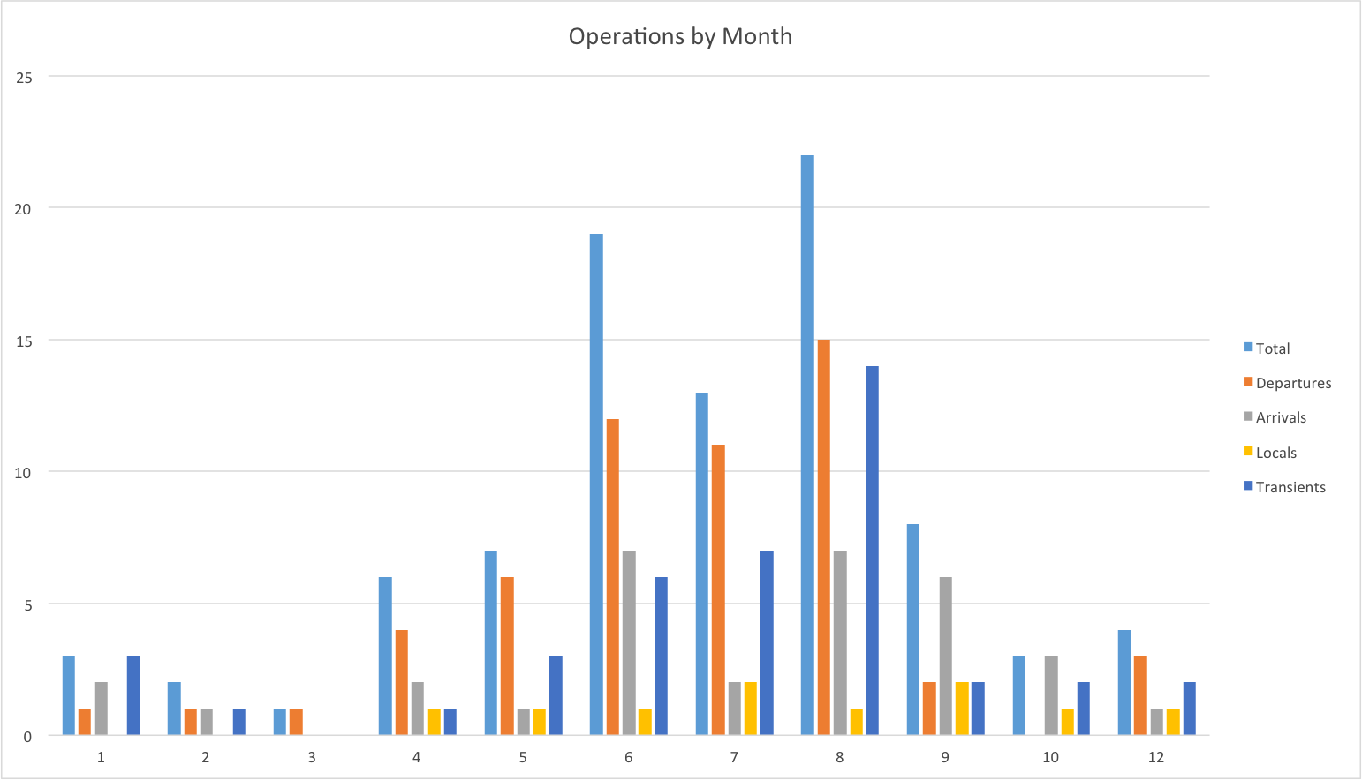

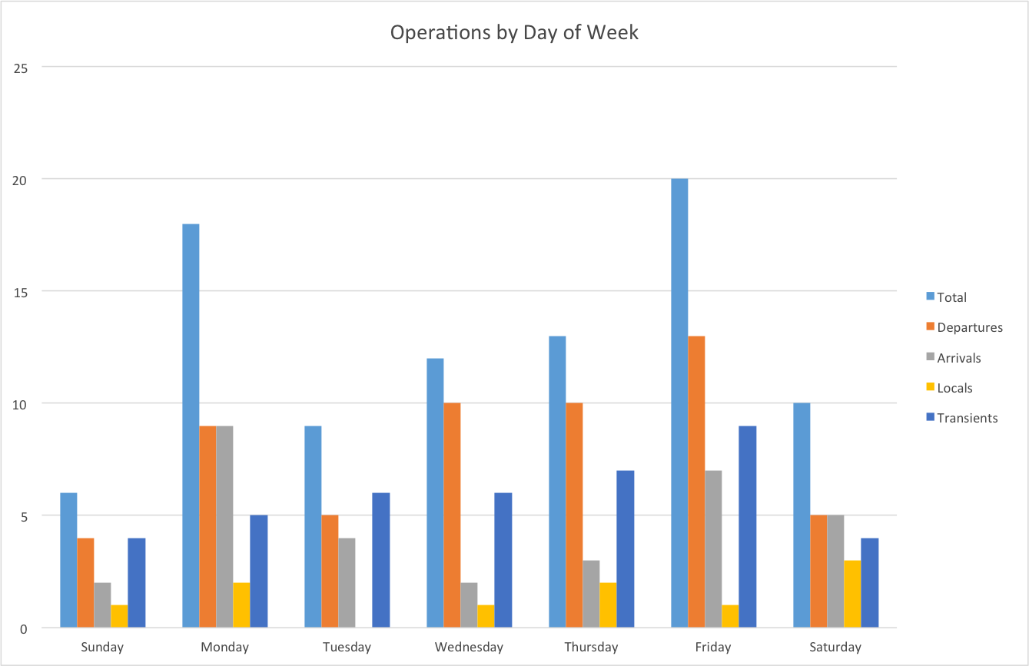

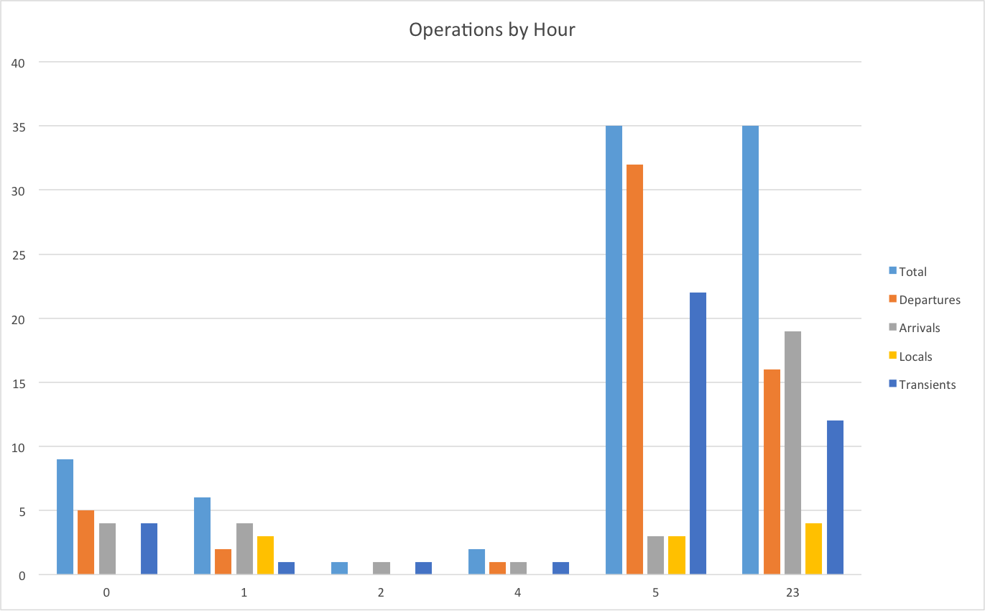

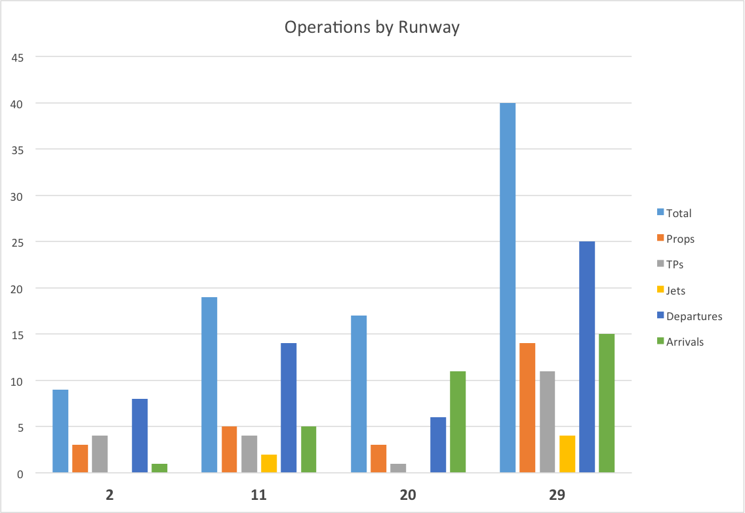

Appendix C: Night Operations Survey
by Mike Cooke, June 2014
6 attempts, 4/6 interviews or replies

Does your company fly into to Truckee after dark?
3 NO, 1 YES

Are there company operational or insurance restrictions that shape your decision to fly here after dark?
3 No, 1 Yes, EJA no vertical guidance.

Are there safety issues or personal minimums that contribute to your decision to fly or not fly here after dark?
All: No ILS, Corp1: not an option period. Chart1 tries to curtail night ops, esp in winter. Chrt2: self-imposed restriction. EJA policy requires vertical guidance.

Does customer demand generally shape operations hours?
All yes, but within operational parameters, ie Corp1 would rather take customers to Reno if they want to come here at night.

Would you like to see enhanced services after dark here? If so what?
All: No, like it the way it is & don’t use the night services anyway. Chrt1: we’re used to the services as they are, so we don’t expect after hours fuel, etc.

If a large hangar were available for overnight use, do you feel it would increase your overnight visits to KTRK?
All: More likely to stay the night even instead of repositioning. Corp1 was even willing to sublease by the month.

Other comments
Summary – all interviewed operators were happy with current situation and would welcome more hangar options for overnight use. Nobody expected increases in night ops or significant changes to schedules.

Appendix D: Fleet Mix Changes
The Master Plan currently being prepared for Truckee Tahoe Airport includes estimates of operational changes and highlights more turbo-prop and turbo-jet based aircraft:

Table 2-26 | 2012 (Actual) | 2015 | 2020 | 2025
BASED AIRCRAFT:
Single‐Engine Piston | 156 | 157 | 158 | 160
Multi‐Engine Piston | 12 | 12 | 12 | 12
Turbo‐Prop | 27 | 29 | 34 | 41
Turbo‐Jet | 16 | 18 | 24 | 32
Helicopter | 6 | 6 | 7 | 8
TOTAL1 | 217 | 222 | 236 | 253
OPERATIONS
Itinerant | 14,902 | 15,687 | 17,087 | 18,612
Local | 11,568 | 11,777 | 12,142 | 12,527
TOTAL | 26,470 | 27,464 | 29,229 | 31,139
PEAK CONDITIONS:
Peak Month (July) | 4,922 | 5,034 | 5,244 | 5,467
(% annual) | (18.60%) | (18.29%) | (17.83%) | (17.36%)
Average Day/ Peak Month | 164 | 168 | 175 | 182
Peak Hour (15%) | 25 | 25 | 26 | 27
Truckee Tahoe Airport, “Aviation Forecasts,” Truckee Tahoe Master Plan (Draft), June 2014, http://www.ttadmasterplan.org/wp-content/uploads/2014/06/ TRK%20AMP%20June%202014%20DRAFT.C2.Forecasts.pdf

Newer aircraft tend to be better equipped and fleet mix is changing from single-engine pistons (actually decreasing) to high-end airframes that tend to be better equipped. Hence as the aviation market progresses it is likely that the capability of aircraft to operate in darkness will continue to improve and expand. The aircraft will not be a barrier to operating in darkness.

Appendix E: Operations During Darkness, Selected Periods of 2013-2014

Tabular Data

July-August 2013
Date/Time | Operation | Runway | Operator | Aircraft | Type | Count
7/2/13 9:21 PM | A | 29 |  |  |  | 1
7/2/13 9:41 PM | D | 20 |  |  |  | 1
7/5/13 9:24 PM | D | 29 | Charter | Pilatus PC12 | TP | 1
7/6/13 9:18 PM | D | 29 | Individual | Cessna 206 | P | 1
7/8/13 5:47 AM | D | 11 |  |  |  | 1
7/10/13 11:36 PM | A | 11 |  | Mooney M20K | P | 1
7/11/13 5:47 AM | D | 29 |  | Cessna 182 | P | 1
7/11/13 9:02 PM | A | 11 | Corporate | Gulfstream G150 | J | 1
7/11/13 9:31 PM | D | 29 | Corporate | Gulfstream G150 | J | 1
7/13/13 9:18 PM | A | 29 | Individual | Piper Malibu | P | 1
7/14/13 9:01 PM | A | 11 | Individual | Robinson R44 | H | 1
7/14/13 11:16 PM | A | 29 |  | Cessna T210 | P | 1
7/15/13 9:25 PM | A | 29 |  |  |  | 1
7/15/13 11:01 PM | D | 29 |  | Lear 35A | J | 1
7/17/13 10:04 PM | D | UNK | Individual | Cessna 310 | P | 1
7/18/13 9:16 PM | A | 20 |  | Unk |  | 1
7/20/13 9:36 PM | A | 11 | Corporate | King Air 200 | TP | 1
7/20/13 9:53 PM | D | 11 | Corporate | Citation 525A | J | 1
7/21/13 9:47 PM | A | 29 |  |  |  | 1
7/23/13 9:04 PM | A | 29 |  |  |  | 1
7/24/13 8:59 PM | D | 11 |  |  |  | 1
7/25/13 9:14 PM | A | 29 |  |  |  | 1
7/25/13 9:29 PM | D | 29 | Individual | Piper Malibu | P | 1
7/29/13 5:58 AM | D | 20 |  |  |  | 1
7/30/13 10:46 PM | D | 29 | Charter | Cessna 414 | P | 1
8/1/13 12:19 AM | A | 29 |  | Pilatus PC12 | TP | 1
8/1/13 8:24 PM | A | UNK |  |  |  | 1
8/2/13 5:31 AM | D | 29 |  |  |  | 1
8/2/13 8:32 PM | A | 29 |  |  |  | 1
8/2/13 8:34 PM | A | 11 |  |  |  | 1
8/3/13 8:36 PM | D | 29 | Individual | Beech Bonanza | P | 1
8/3/13 8:53 PM | A | 29 | Corporate | Citation 525 | J | 1
8/3/13 9:40 PM | D | 29 | Individual | Beech Bonanza | P | 1
8/3/13 9:54 PM | D | 29 | Charter | Citation 525 | J | 1
8/4/13 5:45 AM | D | 29 |  |  |  | 1
8/4/13 8:59 PM | A | 29 | Individual | Cessna 210 | P | 1
8/4/13 9:10 PM | A | 11 |  |  |  | 1
8/4/13 9:32 PM | D | 29 | Corporate | Cessna 340 | P | 1
8/4/13 10:48 PM | A | 29 |  |  |  | 1
8/5/13 4:16 AM | A | 11 |  | Cessna 750 | J | 1
8/5/13 5:38 AM | D | 11 |  | Cessna 750 | J | 1
8/5/13 8:35 PM | D | 2 | Individual | Cessna 210 | P | 1
8/7/13 8:24 PM | D | 29 | Corporate | King Air 200 | TP | 1
8/8/13 8:30 PM | D | 29 | Charter | Pilatus PC12 | TP | 1
8/8/13 8:36 PM | A | 29 |  |  |  | 1
8/8/13 9:02 PM | A | 29 | Individual | Mooney M20 | P | 1
8/8/13 9:23 PM | D | 29 | Corporate | Citation 550 | J | 1
8/9/13 8:33 PM | D | 29 | Corporate | King Air 200 | TP | 1
8/9/13 9:04 PM | A | 29 | Individual | Cessna 210 | P | 1
8/9/13 9:13 PM | A | 29 |  |  |  | 1
8/10/13 10:23 PM | A | 20 | Individual | Pilatus PC12 | TP | 1
8/10/13 10:35 PM | D | 29 | Individual | Pilatus PC12 | TP | 1
8/11/13 9:03 PM | D | 29 | Individual | Cirrus SR20 | P | 1
8/13/13 8:43 PM | A | 29 | Individual | Beech Bonanza | P | 1
8/14/13 8:49 PM | D | 29 |  |  |  | 1
8/16/13 8:53 PM | A | 11 |  |  |  | 1
8/16/13 9:23 PM | A | 29 |  |  |  | 1
8/16/13 10:11 PM | D | 29 |  |  |  | 1
8/17/13 8:55 PM | A | 11 |  |  |  | 1
8/22/13 8:29 PM | A | 29 |  |  |  | 1
8/23/13 9:02 PM | D | UNK | Individual | Cessna 210 | P | 1
8/25/13 8:25 PM | A | 20 | Individual | Cessna 310 | P | 1
8/25/13 9:09 PM | A | 29 | Corporate | Cessna 525 | J | 1
8/25/13 9:20 PM | D | 29 | Corporate | Cessna 525 | J | 1
8/25/13 11:11 PM | D | 29 |  | Gulfstream G-IV | J | 1
8/27/13 5:31 AM | A | 29 |  | Cessna 525B | J | 1
8/27/13 6:00 AM | D | 29 |  | Cessna 525B | J | 1
8/28/13 5:33 AM | D | 29 |  | Diamond DA40 | P | 1
8/29/13 9:26 PM | A | 11 |  |  |  | 1
8/30/13 5:03 AM | D | 20 |  | Beech V35 | P | 1
8/30/13 8:36 PM | A | 29 |  |  |  | 1
Totals |  |  |  |  |  | 71

December 2013 - January 2014

Date/Time | Operation | Runway | Operator | Aircraft | Type | Count
12/1/13 5:17 PM | D | 29 | Individual | Pilatus PC12 | TP | 1
12/1/13 5:42 PM | A | 29 |  |  |  | 1
12/2/13 9:08 PM | D | 29 |  |  |  | 1
12/5/13 5:23 PM | D | 29 | Individual | Bonanza | P | 1
12/5/13 5:25 PM | D | 29 | Individual | Cessna 210 | P | 1
12/5/13 5:36 PM | A | 29 |  |  |  | 1
12/5/13 6:59 PM | A | 29 | Individual | Cirrus SR22 | P | 1
12/5/13 9:19 PM | A | 29 |  |  |  | 1
12/7/13 10:49 PM | D | 29 |  |  |  | 1
12/8/13 5:27 PM | D | 29 |  |  |  | 1
12/8/13 5:38 PM | D | 29 |  |  |  | 1
12/8/13 5:59 PM | D | 29 | Individual | TBM700 | TP | 1
12/11/13 5:23 PM | A | 29 |  |  |  | 1
12/11/13 6:33 PM | D | 29 |  |  |  | 1
12/11/13 7:09 PM | A | 29 | Individual | Bonanza | P | 1
12/11/13 7:20 PM | D | 29 | Individual | Bonanza | P | 1
12/12/13 5:28 PM | A | 29 |  |  |  | 1
12/12/13 6:45 PM | D | 29 |  |  |  | 1
12/13/13 5:28 PM | A | 29 | Corporate | C25A | J | 1
12/13/13 5:36 PM | A | 29 | Individual | Bonanza | P | 1
12/13/13 5:44 PM | A | 29 | Individual | Cessna 210 |  | 1
12/13/13 5:51 PM | A | 29 |  |  |  | 1
12/13/13 5:52 PM | A | 29 |  |  |  | 1
12/13/13 5:52 PM | A | 29 | Individual | TBM700 | TP | 1
12/13/13 5:53 PM | A | 29 | Individual | Cirrus SR22 | P | 1
12/13/13 5:57 PM | A | 29 | Individual | Cessna 441 | TP | 1
12/13/13 6:52 PM | A | 29 |  |  |  | 1
12/16/13 6:01 PM | A | 29 | Individual | Cessna 182 | P | 1
12/17/13 5:17 PM | A | 29 | Individual | Cirrus SR22 | P | 1
12/17/13 5:27 PM | A | 29 | Individual | Pilatus PC12 | TP | 1
12/18/13 5:15 PM | D | 29 | Corporate | Pilatus PC12 | TP | 1
12/18/13 5:26 PM | A | 29 |  |  |  | 1
12/18/13 10:23 PM | A | 29 |  |  |  | 1
12/18/13 10:24 PM | A | 29 | Corporate | Pilatus PC12 | TP | 1
12/19/13 5:22 PM | D | 29 | Individual | Pilatus PC12 | TP | 1
12/20/13 5:54 PM | A | 29 |  |  |  | 1
12/20/13 6:38 PM | A | 29 |  |  |  | 1
12/20/13 7:39 PM | A | 29 |  |  |  | 1
12/21/13 5:19 PM | A | 29 | Individual | Cessna 421 |  | 1
12/21/13 5:27 PM | D | 29 | Charter | Pilatus PC12 | TP | 1
12/21/13 5:33 PM | A | 29 |  |  |  | 1
12/21/13 5:33 PM | D | 29 | Corporate | Cessna 525 | J | 1
12/21/13 7:40 PM | A | 29 |  |  |  | 1
12/22/13 5:25 PM | A | 29 | Individual | Bonanza |  | 1
12/22/13 5:30 PM | D | 29 | Individual | Piper PA32 |  | 1
12/22/13 5:31 PM | D | 29 |  |  |  | 1
12/22/13 6:11 PM | A | 29 |  |  |  | 1
12/22/13 6:14 PM | A | 29 |  |  |  | 1
12/22/13 6:51 PM | D | 29 |  |  |  | 1
12/22/13 7:27 PM | A | 29 | Charter | Pilatus PC12 | TP | 1
12/22/13 8:05 PM | D | 29 | Charter | Pilatus PC12 | TP | 1
12/22/13 8:43 PM | D | 29 | Charter | C650 |  | 1
12/23/13 6:49 PM | A | 29 | Individual | TBM700 |  | 1
12/24/13 5:17 PM | A | 29 |  |  |  | 1
12/26/13 5:28 PM | D | 29 | Charter | C25 | J | 1
12/26/13 5:29 PM | A | 29 | Corporate | Hawker 400 | J | 1
12/26/13 5:43 PM | A | 29 |  |  |  | 1
12/26/13 6:07 PM | D | 29 | Corporate | Hawker 400 | J | 1
12/26/13 6:36 PM | D | 29 |  |  |  | 1
12/27/13 5:33 PM | A | 29 | Charter | Kodiak | TP | 1
12/27/13 5:57 PM | D | 29 | Charter | Kodiak | TP | 1
12/27/13 6:31 PM | A | 29 | Individual | Cessna182 | P | 1
12/27/13 8:24 PM | A | 29 | Individual | TBM700 | TP | 1
12/28/13 6:24 PM | D | 29 |  |  |  | 1
12/29/13 5:19 PM | A | 29 |  |  |  | 1
12/29/13 7:02 PM | A | 29 |  |  |  | 1
12/29/13 8:19 PM | A | 29 | Individual | Pilatus PC12 | TP | 1
12/30/13 6:36 AM | D | 29 |  |  |  | 1
12/30/13 7:48 PM | D | 29 | Charter | Hawker 800 | J | 1
12/31/13 6:02 PM | A | 29 |  |  |  | 1
1/1/14 5:20 PM | D | 29 |  |  |  | 1
1/1/14 6:37 PM | A | 29 | Corporate | C25A | J | 1
1/1/14 6:49 PM | D | 29 | Corporate | C25A | J | 1
1/1/14 7:40 PM | A | 29 | Corporate | C25B | J | 1
1/1/14 7:54 PM | D | 29 | Corporate | C25B | J | 1
1/1/14 9:18 PM | A | 29 | Individual | Pilatus PC12 | TP | 1
1/2/14 7:34 PM | D | 29 | Charter | BE30 | TP | 1
1/3/14 6:47 AM | D | 29 |  |  |  | 1
1/3/14 5:44 PM | A | 29 | Individual | Cirrus SR22 | P | 1
1/3/14 6:23 PM | A | 29 | Charter | Epic LT | TP | 1
1/3/14 6:27 PM | A | 29 | Fractional | Pilatus PC12 | TP | 1
1/3/14 6:47 PM | D | 29 | Fractional | Pilatus PC12 | TP | 1
1/4/14 5:29 PM | D | 29 |  |  |  | 1
1/5/14 5:17 PM | D | 29 | Individual | Pilatus PC12 | TP | 1
1/5/14 7:36 PM | A | 29 | Charter | Pilatus PC12 | TP | 1
1/5/14 7:55 PM | D | 29 | Charter | Pilatus PC12 | TP | 1
1/6/14 6:33 AM | D | 29 |  |  |  | 1
1/6/14 6:21 PM | A | 29 | Individual | Pilatus PC12 | TP | 1
1/8/14 5:33 PM | A | 29 | Individual | Pilatus PC12 | TP | 1
1/8/14 5:45 PM | A | 29 | Individual | R44 | H | 1
1/9/14 6:38 PM | A | 29 |  |  |  | 1
1/10/14 5:19 PM | D | 29 | Individual | Cessna 206 |  | 1
1/10/14 5:24 PM | A | 29 | Individual | Pilatus PC12 | TP | 1
1/10/14 5:26 PM | A | 29 |  |  |  | 1
1/10/14 6:08 PM | A | 29 | Individual | Cirrus SR22 | P | 1
1/10/14 6:13 PM | A | 29 | Individual | Pilatus PC12 | TP | 1
1/10/14 7:15 PM | A | 29 |  |  |  | 1
1/10/14 7:29 PM | A | 29 |  |  |  | 1
1/10/14 7:31 PM | A | 29 |  |  |  | 1
1/10/14 7:44 PM | A | 29 | Corporate | Cessna 414 | P | 1
1/10/14 8:03 PM | D | 29 | Corporate | Cessna 414 | P | 1
1/12/14 5:23 PM | D | 29 |  |  |  | 1
1/12/14 5:52 PM | D | 29 |  |  |  | 1
1/13/14 5:18 PM | A | 29 | Individual | Lancair | P | 1
1/15/14 5:17 PM | D | 29 |  |  |  | 1
1/15/14 6:09 PM | A | 29 |  |  |  | 1
1/15/14 6:31 PM | A | 29 |  |  |  | 1
1/15/14 6:43 PM | A | 29 | Individual | Cirrus SR22 | P | 1
1/16/14 6:43 AM | D | 29 | Individual | Cessna 310 | P | 1
1/16/14 5:16 PM | A | 29 | Individual | Mooney | P | 1
1/16/14 5:21 PM | A | 29 |  |  |  | 1
1/16/14 5:29 PM | A | 29 | Chart8 | Cessna 510 | J | 1
1/17/14 5:17 PM | D | 29 | Charter | Pilatus PC12 | TP | 1
1/17/14 5:24 PM | A | 29 | Fractional | BE40 | J | 1
1/17/14 6:45 PM | A | 29 | Charter | Pilatus PC12 | TP | 1
1/17/14 7:07 PM | A | 29 | Individual | Cessna 441 | TP | 1
1/17/14 7:18 PM | A | 29 | Individual | Cessna 310 | P | 1
1/17/14 7:50 PM | D | 29 | Individual | Cessna 441 | TP | 1
1/17/14 8:08 PM | A | 29 | Individual | Pilatus PC12 | TP | 1
1/17/14 11:11 PM | A | 29 | Charter | BE40 | J | 1
1/17/14 11:24 PM | D | 29 |  |  |  | 1
1/17/14 11:26 PM | D | 29 | Charter | BE40 | J | 1
1/18/14 5:21 PM | A | 29 | Individual | Lancair | P | 1
1/18/14 5:30 PM | A | 29 |  |  |  | 1
1/20/14 5:29 PM | A | 29 |  |  |  | 1
1/20/14 5:57 PM | A | 29 | Individual | Pilatus PC12 | TP | 1
1/20/14 6:01 PM | A | 29 |  |  |  | 1
1/20/14 6:14 PM | D | 29 | Individual | Pilatus PC12 | TP | 1
1/20/14 6:47 PM | A | 29 | Individual | Bonanza | P | 1
1/20/14 6:57 PM | D | 29 |  |  |  | 1
1/20/14 6:58 PM | D | 29 | Individual | Bonanza | P | 1
1/20/14 8:28 PM | A | 29 | Individual | TBM700 | TP | 1
1/21/14 5:17 PM | D | 29 | Individual | TBM700 | TP | 1
1/21/14 5:45 PM | A | 29 | Individual | Bonanza |  | 1
1/21/14 7:32 PM | A | 29 | Individual | Cirrus SR22 | P | 1
1/22/14 5:17 PM | D | 29 | Fractional | CL60 | J | 1
1/22/14 5:23 PM | D | 29 | Individual | Cessna 182 | P | 1
1/22/14 5:40 PM | A | 29 | Individual | Bonanza | P | 1
1/22/14 6:37 PM | A | 29 |  |  |  | 1
1/23/14 5:23 PM | D | 29 |  |  |  | 1
1/23/14 5:38 PM | A | 29 | Individual | Cessna 182 | P | 1
1/23/14 6:02 PM | D | 29 |  |  |  | 1
1/23/14 11:00 PM | D | 29 |  |  |  | 1
1/24/14 5:15 PM | A | 29 |  |  |  | 1
1/24/14 5:16 PM | A | 29 |  |  |  | 1
1/24/14 5:17 PM | D | 29 | Charter | Pilatus PC12 | TP | 1
1/24/14 5:18 PM | A | 29 | Individual | Bonanza |  | 1
1/24/14 5:22 PM | A | 29 | Individual | Cessna 210 | P | 1
1/24/14 5:46 PM | A | 29 |  |  |  | 1
1/24/14 5:53 PM | A | 29 | Charter | Cessna 560XL | J | 1
1/24/14 6:52 PM | A | 29 |  |  |  | 1
1/24/14 8:11 PM | A | 29 | Charter | Pilatus PC12 | TP | 1
1/24/14 8:29 PM | D | 29 | Charter | Pilatus PC12 | TP | 1
1/25/14 5:25 PM | D | 29 |  |  |  | 1
1/25/14 5:44 PM | A | 29 |  |  |  | 1
1/25/14 5:49 PM | A | 29 | Charter | Pilatus PC12 | TP | 1
1/25/14 6:05 PM | D | 29 | Charter | Pilatus PC12 | TP | 1
1/26/14 5:31 PM | A | 29 | Individual | Cessna 310 | P | 1
1/26/14 5:37 PM | D | 29 |  |  |  | 1
1/26/14 6:50 PM | A | 29 | Charter | Pilatus PC12 | TP | 1
1/26/14 7:48 PM | D | 29 | Charter | Pilatus PC12 | TP | 1
1/27/14 6:59 PM | D | 29 |  |  |  | 1
1/28/14 5:22 PM | D | 29 |  |  |  | 1
1/28/14 5:36 PM | D | 29 |  |  |  | 1
1/28/14 6:58 PM | A | 29 | Individual | Pilatus PC12 | TP | 1
Total |  |  |  |  |  | 165

Graphs
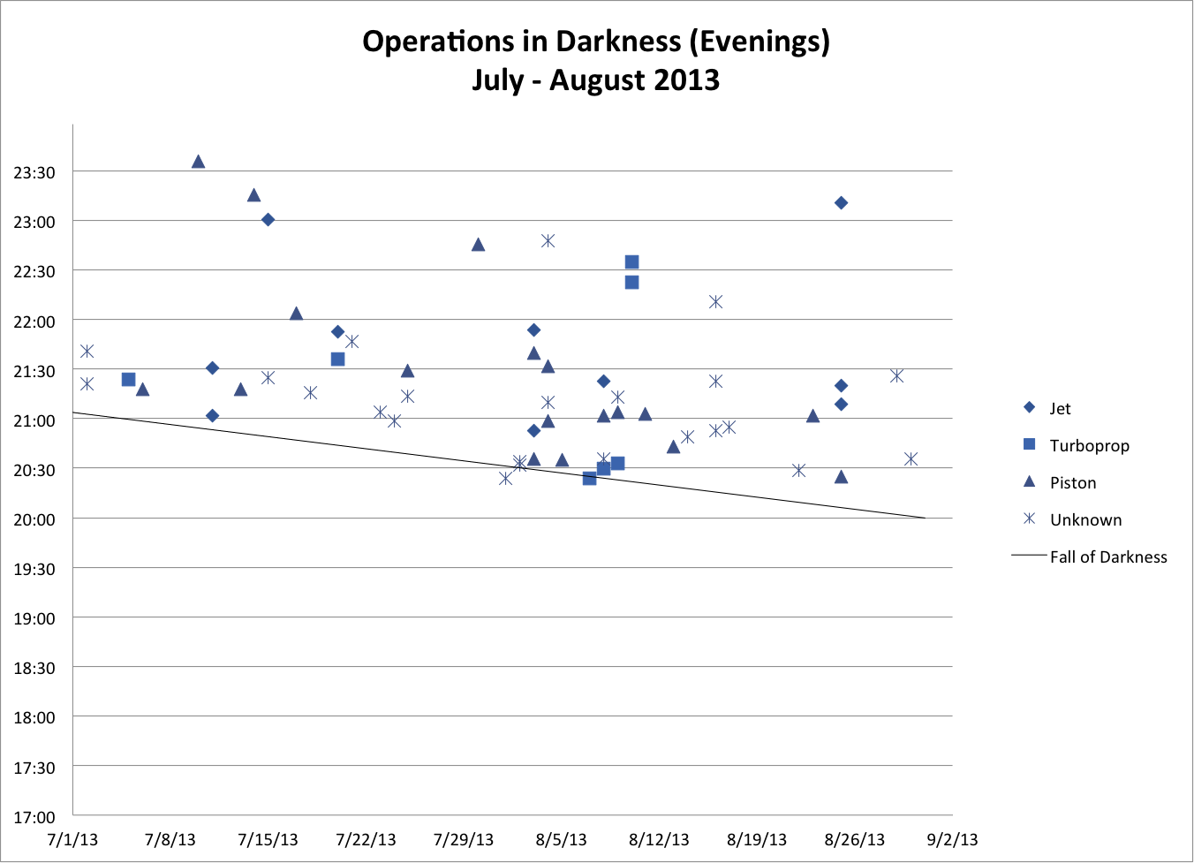
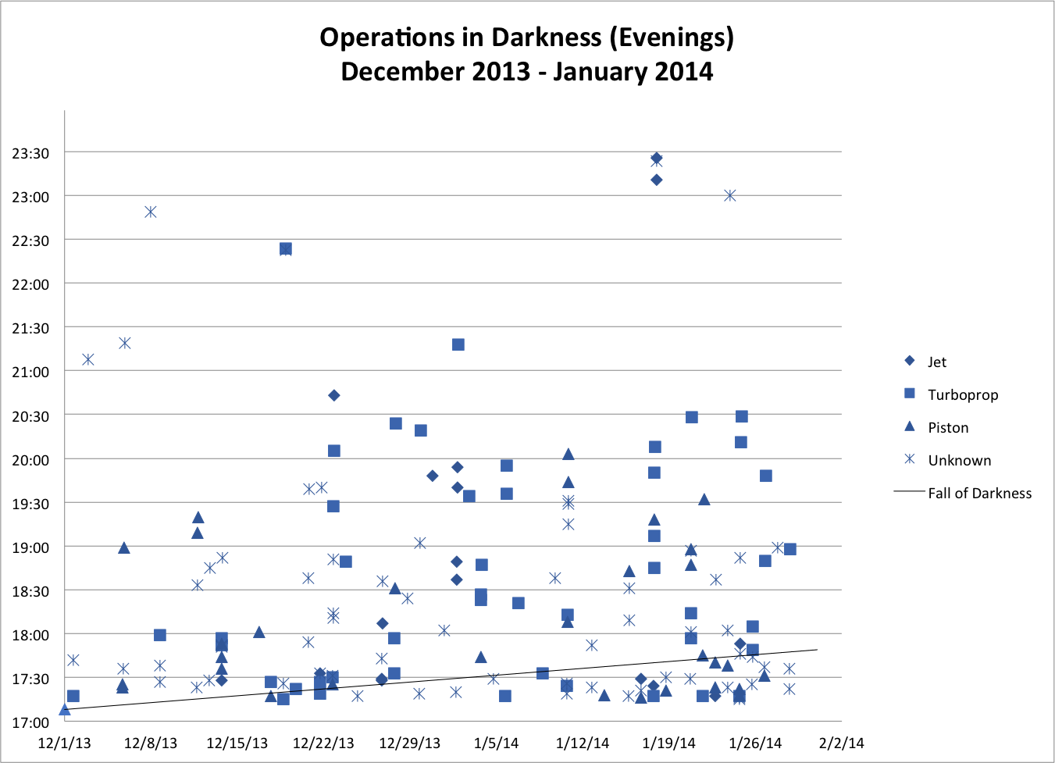
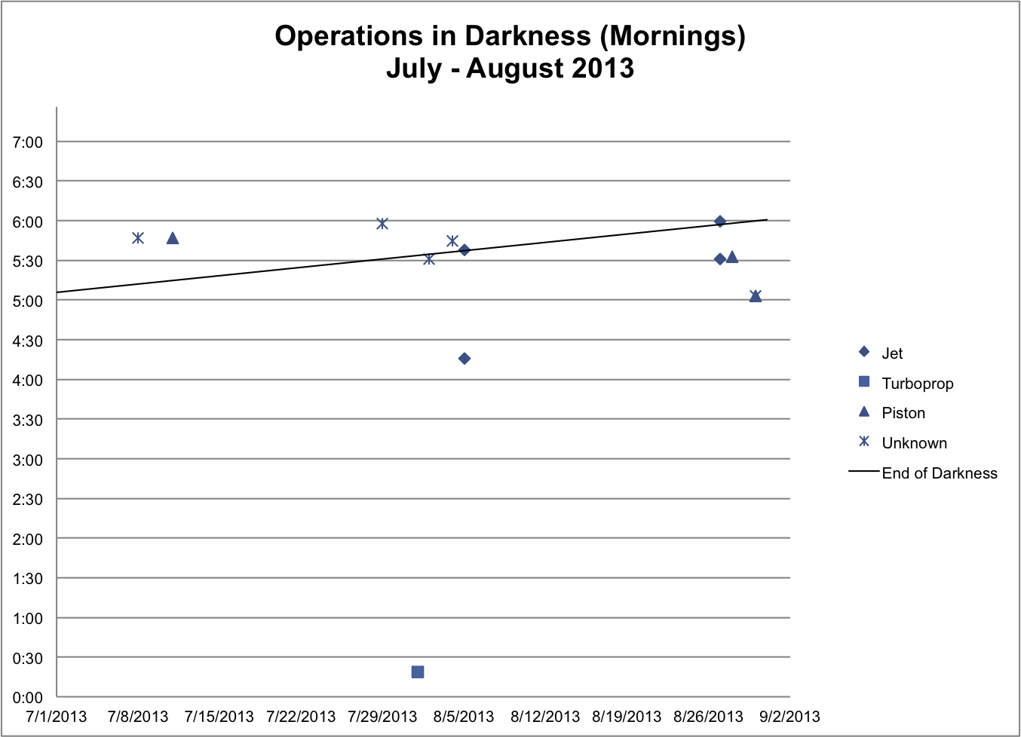
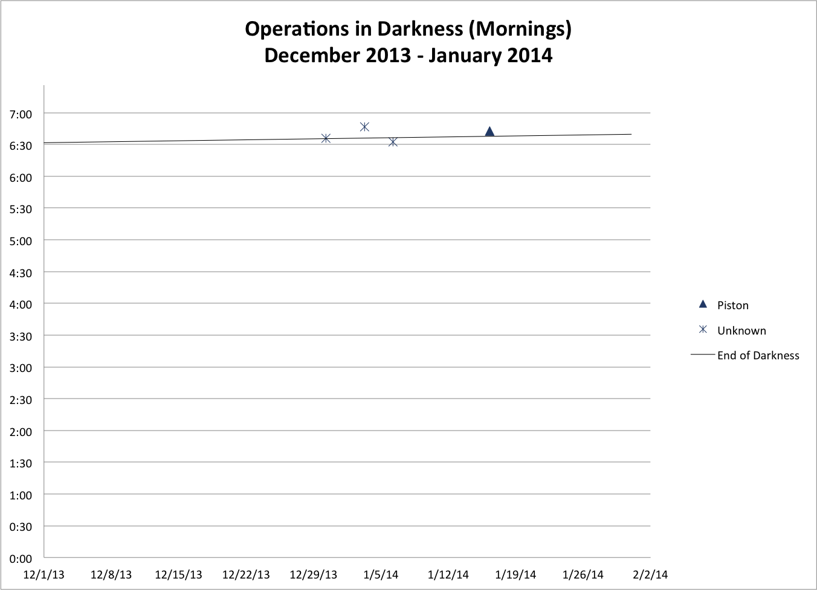

Appendix F: TTAD Board of Directors, Agenda Item, Curfew/Night Operations Restrictions

Background

- Airport currently has voluntary curfew from 11PM-6AM.

- Few night operations occur at TRK due to terrain and company SOP’s

- 32 calls (7%) 10PM-7AM in 2003, 12 calls on one event

- Night ops receive a +10db penalty by the State of California standards (CNEL)

Options
1. Formal Curfew: Airport remains open at night to some aircraft that meet certain noise criteria defined by the airport and approved by the FAA. Part 161 study required. Possible litigation following completion of study. No airport has successfully completed and implemented a Part 161 study since ANCA was passed in 1990. The Bob Hope-Burbank Airport has spent over $2 million and the study is not yet complete. Enforcement would require punitive component.

2. Reduced service hours: Further reduction in AC service hours (10PM-7AM proposed) could help deter night operations. Hours align with penalty period for aircraft noise as measured by State of California. Minimal financial impact. Simple and inexpensive to implement. No FAA involvement required.

3. Close airport at night: Eliminates all night ops. Could violate FAA grant assurances 19 and 22 (see attachment). Airport’s potential as emergency landing site for trans-Sierra flights minimized if lighting system disable after dark. Would require punitive component to enforce compliance.

4. Ban type(s) of aircraft: Discriminatory practice violates grant assurances unless Part 161 study completed. See #1.

- No change: Continue to request voluntary curfew and monitor operations.

Analysis
Based on the low volume of night operations and minimal amount of night noise calls, cost-benefits should be carefully considered. Reduction in service hours would be inexpensive and simple to implement. Options 1, 3 and 4 create financial and safety issues. Most importantly, any alternative would have little impact on overall operations due to low volume of night activity.

Appendix G: 2006 ACAT Part 161 Study Recommendation

FAA Part 161 Study Recommendation
Airport Community Advisory Team (ACAT)
Truckee Tahoe Airport District
April 2006

Board Action Requested: Vigorously monitor and encourage voluntary curfew while studying further need for mandatory curfew with consideration of future conditions. Collect more data. Reconsider options as needed or in 12 months.

Background
At the Truckee Tahoe Airport District Board of Directors Workshop on February 7, 2006 there was discussion regarding the possibility of conducting a Part 161 Study to result in some form of access restrictions at the Truckee Tahoe Airport (TRK). The Board, Airport Community Advisory Team (ACAT) and staff have been briefed by special legal counsel Peter Kirsch, and noise consultants HMMH on issues surrounding both Part 150 and Part 161.
The primary purpose of these restrictions would be to limit aircraft operations impacts on the surrounding community, especially during the nighttime hours. The purpose of this paper is to summarize the current regulations that control the implementation of access restrictions and provide a description of some activities other airports have undertaken in order to facilitate discussion on this subject relevant to TRK.
The Airport Noise and Capacity Act (ANCA) was enacted by Congress in 1990. ANCA is legislation that was passed by Congress to institute the gradual phase out of older “Stage 2” aircraft over 75,000 pounds in gross weight to quieter “Stage 3” aircraft by the end of the year 2000. The Act also regulated the adoption of restrictions on Stage 2 and 3 aircraft by airports. The intent was to reduce off- airport noise impacts by reducing noise generated at the source.
Prior to ANCA, FAR Part 150 required the airport to demonstrate that the proposed access restriction would first not unjustly discriminate against a single operator or type of aircraft and secondly, not create an undue burden on interstate commerce. Part 161 was created with the genesis of ANCA to allow airports a process by which to legally implement access and operations restrictions.

FAA Guidelines & Criteria
The Truckee Tahoe Airport District (TTAD) and the Airport Community Advisory Team (ACAT) have been investigating the applicability of a Part 161 study to the current and future situation at Truckee Tahoe Airport (TRK). The Part 161 process is used to adopt or implement a noise or use restriction at an airport.
The FAA recommends an incremental approach to noise control at airports. The Part 161 study and restrictions are seen as measures of last resort. The FAA requires that the Part 161 study demonstrate that any restrictive measure achieves noise reduction benefits (areas inside the 65db CNEL contour) not met by other non-restrictive measures. It also requires identification and evaluation of alternative restrictive options to meet the stated goal. Data to support the options is required.
After ANCA was passed, FAR Part 161 added more restrictive criteria. In addition to unjust discrimination and burdens on interstate commerce, an airport must now demonstrate the restriction complies with the following:
- Provides an adequate analysis of the costs and benefits of the proposed restriction and alternative measures.
- The restriction is reasonable, non arbitrary and non-discriminatory.
- The restriction maintains safe and efficient use of navigable airspace.
- The restriction does not conflict with any existing federal statute or regulation.
- The applicant has provided adequate opportunity for public comment on the proposed restriction.
- The restriction does not create an undue burden on the National Aviation System.
- The study must also account for the noise impact on the receiving communities if the restricted flights are presumed to be diverted.

Other Airports
While each community and airport is unique, it is important for TTAD to be conscious of the experiences of other airports. With the exception of the Naples airport, the following airports began studies and never submitted them to the FAA for various reasons:
- Kahului Airport, Kahulu i, Maui, Hawaii
The state of Hawaii was exempted from some ANCA provisions due to the significant role of air transportation in the economy. Stage 2 aircraft operating inter-island flights were exempted and capped, thus allowing commercial operations past the year 2000. Kahului Airport, owned and operated by the State of Hawaii, unsuccessfully pursued a ban on night commercial Stage 2 aircraft operations.
The FAA stated in preliminary correspondence, “A local phase out requirement would also frustrate the national aviation noise policy because action by the State of Hawaii to impose a local phase out at Kahului would prompt similar or more stringent restrictions on operations by Stage 2 aircraft at its other airports. A patchwork of airport use restrictions is the kind of situation that Congress sought to avoid by adopting the Act…” The FAA clearly did not want to allow local restrictions based on aircraft stage and time of operation.
- Minneapolis-St. Paul International Airport, Minneapolis, Minnesota
The Metropolitan Airports Commission (MAC) prepared a Part 161 notice and analysis in July 2000 to adopt revisions to current MAC Ordinance 51 to implement a nighttime curfew on Stage 2 jet operations and a nighttime curfew on maintenance run-ups at Flying Cloud Airport (FCM – located in the City of Eden Prairie). MAC was also proposing to revise Ordinance 51 to prohibit scheduled airline and Part 121 cargo operations at FCM.
The FAA commented to the MAC that the mandatory restrictions outlined in the Part 161 notice and analysis were discriminatory and therefore inconsistent with the conditions of receiving federal grants. As a result, the MAC discontinued the Part 161 process to implement the mandatory restrictions and instead replaced Ordinance 51 with Ordinance 97. The new ordinance prohibits maintenance run-ups between the hours of 10 p.m. and 7 a.m. and restricts the use of the airport to only aircraft weighing less than 60,000 pounds certified max gross takeoff weight, dual wheel (runway weight bearing capacity). The new 60,000 pound restriction was a relaxation of the existing 20,000 pound restriction in Ordinance 51 and therefore was acceptable to the FAA.
- San Francisco International, San Francisco, CA
As a precursor to the San Francisco International Airport (SFO) Part 161 Study, HMMH developed a FAR Part 161.205 (Stage 2 restriction) work scope for the City and County of San Francisco for a proposed expansion of the nighttime curfew on Stage 2 operations at SFO. Specifically, the proposed airport use restriction evaluated under FAR Part 161 was a restriction, beginning on January 1,1999 of landing and takeoff operations by Stage 2 aircraft greater than 75,000 pounds between the hours of 20:00 to 08:00.
The study evaluated noise effects and cost benefits of Stage 2 restrictions for two alternative periods: (1) 21:00 to 08:00 and (2) 22:00 to 08:00. Each of the potential restrictions was an extension of an existing restriction at SFO. At the time, San Francisco International Airport Noise Abatement Regulations, Resolution No. 88-016 as amended through January 17, 1995 by Resolution No. 95-0015, which were grandfathered under the Aircraft Noise and Capacity Act, restricted operations of Stage 2 aircraft greater than 75,000 pounds from operating between 23:00 and 07:00.
During the Part 161 study, HMMH carefully examined the impact of the restrictions on nighttime all-cargo aircraft operations. The study concluded that the benefit (in terms of noise reduction) of implementing the restriction outweighed the cost to the airlines. The SFO FAR Part 161 Study was the first Part 161 study submitted to the Federal Aviation Administration for review. SFO elected to withdraw the study when the airlines agreed to implement voluntary noise reduction measures that accomplished the same goals as the Part 161 study.
- San Jose International, San Jose, CA
The City of San Jose hired HMMH to prepare a Part 161 work scope that met all of the requirements of FAR Part 161 while accounting for requirements generated by agreements with Citizens Against Airport Pollution (CAAP) and the on-going airport Master Plan Update. The Part 161 was contemplated to enact Stage 2 aircraft noise restrictions.
As a follow on to the San José International Airport (SJC) Part 161 Work Scope Development project, the City of San Jose hired HMMH to conduct a Part 161 Study. HMMH examined the noise effects and benefits- costs associated with two potential Stage 2 restrictions: 1) a complete ban on Stage 2 aircraft operations and 2) a collapsing curfew; during which Stage 2 aircraft would have fewer and fewer hours to operate at SJC as the Year 2000 approached. The study was completed within the 12-month schedule dictated by the stipulated agreement between the City of San José and Citizens Against Airport Pollution (CAAP).
The SJC Part 161 Study revealed several important facts: while some passenger carriers would experience economic losses due to the restrictions, others would experience economic gains from substituting more efficient Stage 3 aircraft for a Stage 2 aircraft; one cargo carrier would leave SJC completely and resume operations at the next closest air carrier airport; lost secondary spending (hotel rooms, meals, etc.) within the City of San José, due to passengers shifting to other Bay-area airports, was significant; and, most important, there was not enough time between the date of implementation of the Stage 2 restrictions and the Year 2000 for the economic benefits (i.e., reduced sound insulation costs) to overcome the costs of the restrictions.
The SJC Part 161 Study was the first full Part 161 study undertaken under the Aircraft Noise and Capacity Act and remains the model upon which all Part 161 studies to date have been based.
- Bob Hope/ Glendale, Pasadena, Burbank Airport
Burbank, CA (BUR) began a Part 161 study on July 15, 2000 with the goal, “To eliminate or significantly reduce nighttime flight noise at Burbank Airport now and in the future.” The study ceased in late 2003 after preliminary review from the FAA indicating a complete nighttime curfew was inconsistent with Part 161 criteria.
Specific Wording: The Burbank-Glendale-Pasadena Airport Authority will enact a curfew on all operations by aircraft at BUR between the hours of 10 p.m. and 7 a.m. (local time). The curfew will take effect sixty days following approval. This proposed restriction would be subject to approval by the Federal Aviation Administration under the provisions of Federal Aviation Regulation Part 161.
Exceptions: The following aircraft shall be permitted to land at and takeoff from the Burbank-Glendale-Pasadena Airport between the hours of 10:00 p.m. and 7:00 a.m.:
1. Law enforcement and fire fighting aircraft, military aircraft, aircraft owned or operated by the armed forces of the United States, and aircraft operated in support of military operations.
2. Medical flight aircraft with documentation engaged in active emergency operations for the transportation of patients or human organs.
3. Aircraft delayed in landing and/or takeoff by weather, mechanical, or air traffic control; provided however, that this exception shall not authorize any landing or takeoff between the hours of 11:00 p.m. and 7:00 a.m.
Upon the request of the Airport Authority, the aircraft operator or pilot in command shall document or demonstrate the precise emergency or delay causing conditions resulting in a landing and/or takeoff between the hours of 10:00 p.m. and 7:00 a.m.
Enforcement: Violators penalized by a series of fines and/or sanctions: (Violations are based on a 12 month period):
1st Violation - $1000 Fine
2nd Violation - $2000 Fine
3rd Violation - $3000 Fine
4th Violation - $5000 Fine and action to ban access or terminate lease
After nearly 4 years and $3 million the airport ceased the study of a nighttime curfew for all operations. The Part 161 study was never formally submitted to the FAA.
The success and failures of other airports certainly don’t predict the outcome of a Part 161 by TTAD, however they do provide insight into the FAA process. The Burbank story is interesting because the curfew was “non-discriminatory” (no one was allowed to fly).
- Naples, FL -Stage 2 GA Jet Restriction
Naples is the only airport to successfully implement a restriction with the Part 161 process (and much litigation) since ANCA was established. The Naples study is the only submission that the FAA has found in compliance with Part 161 analysis, documentation, and notification requirements. The airport banned all Stage 2 aircraft in November of 2000. It is important to note that no airport has ever attempted to ban Stage 3 aircraft specifically. Naples used a 60db DNL standard in the assessment of community impact. The standard was previously established by the City and County . Naples spent over $3 million and nearly 4 years conducting the study and litigating.
Burbank and Naples both provide examples of the Part 161 process and its various risks and opportunities. While no two airports are the same, it is important to carefully consider local conditions in the decision to pursue a Part 161 Study.

Truckee Tahoe Airport Conditions and Facts
An assessment of local conditions and facts is important to gauge the impacts of current operations and fleet mix. As actions are considered the decisions must be considered in the interest of future operational scenarios at TRK. The success or failure of very light jets, fuel pricing, avionics advances, and other innovations may or may not have a measurable impact on the community, but possible outcomes must be considered.
The current fleet mix and operational count at TRK is assessed by the UNICOM operator manually in putting each operation into a database. While not all operations are captured, the data is worthwhile for reference purposes. Likewise, staff also records all reports of community annoyance related to aircraft operations in a separate database. The two key indicators from this data are 1) an increase in jet operations, and 2) minimal reported nighttime annoyance. Nighttime is currently defined as 11:00 p.m.-6:00 a.m. based on the voluntary curfew at TRK. It should be noted that the State of California defines nighttime as 10:00 p.m.-7:00 a.m. for purposes of noise modeling.
The key question is “What do we want to accomplish and is a Part 161 Study a tool to consider?” The following facts must be considered:
- No Part 150 Study has been completed by TTAD. Although a Part 150 study is not a requirement, no airport has ever attempted the Part 161 process without a 150 study.
- No homes are currently located within the 65db CNEL contour on the average annual day.
- TTAD estimates night operations (11:00 p.m.- 6:00 a.m.) to be less than 50 per year. No formal data exists making baseline impacts difficult to determine.
- Total reported nighttime annoyance is very low and has decreased over the last three years.
- If a restriction were adopted and implemented, TRK does not currently have the ability to monitor and enforce the requirements.
- Non-restrictive options have not been thoroughly explored and implemented.
While current conditions don’t provide evidence to support a successful Part 161 study, the future conditions of the airport and the community must be considered. Important factors to consider are:
- Population growth in Truckee and the Martis Valley
- Increase in total airport operations
- Change of aircraft fleet mix
- Introduction of very light jets
- Avionics advancements, enabling more operations at night or in inclement weather
- Introduction of next generation air taxi services
No airport has attempted a Part 161 study to prevent conditions that may occur in the future. Special counsel to TTAD has stated, “This would be an interesting approach…” If TRK were to attempt a Part 161 Study this would be the likely approach given current conditions. The opportunities in this approach would be mostly strategic, yet not without risk. Conducting a Part 161 study in a preemptive approach could provide some value in discussions with various stakeholders, but the unknown outcome could weaken its strategic value.
The total cost for a Part 161 study could range from $250,000-$1,000,000 with additional legal costs. While difficult to estimate legal costs, the City of Naples spent nearly $4,000,000 defending the airport in the Part 161 process against the FAA and private parties. Litigation from private parties, AOPA, NBAA and the FAA could follow a Part 161 study at TRK based on briefings from outside legal counsel, Peter Kirsch.

Options for Action
- Do nothing, wait and see.
- Vigorously monitor and encourage voluntary curfew while studying further need for mandatory curfew with consideration of future conditions. Therefore a Part 161 study is not recommended at this time. Collect more data. Reconsider options as needed or in 12 months.
- Conduct Part 161 study, adopt, but don’t implement.
- Conduct Part 161 study, adopt and implement (requires operations monitoring system and police powers for enforcement).

Conclusion & Recommendation
The decision to initiate a Part 161 study should incorporate the likelihood of acceptance by the FAA, overall cost (study and potential litigation), ability to implement and monitor. Finally overall strategic value should be considered.
Based on the current conditions at TRK coupled with the track record of other airports, the likelihood of getting the study approved by the FAA is very small. The ACAT believes that many of the current problems at TRK can be mitigated and/or solved through voluntary means and other programs currently being developed. While the study could provide some strategic value to the airport in discussions with other stakeholders, the large cost of this potential benefit is not supported by the ACAT at this time.
The ACAT does not recommend beginning a Part 161 study for the Truckee Tahoe Airport. The ACAT has not recommended any specific actions that would require a Part 161 study, therefore a Part 161 study is not recommended at this time. The ACAT recommends vigorous monitoring and encouragement of the existing voluntary curfew while studying further need for mandatory curfew with consideration of future conditions. The ACAT further recommends that more data be collected and the options for action be reconsidered as needed or in 12 months.

Appendix H: United States Naval Observatory Astronomical Tables, Truckee, California (2014)

Available at http://aa.usno.navy.mil/data/docs/RS_OneYear.

Add one hour for daylight time, if and when in use.

Sunrise and Sunset

o , o , TRUCKEE, CALIFORNIA Astronomical Applications Dept.
Location: W120 12, N39 20 Rise and Set for the Sun for 2014 U. S. Naval Observatory
Washington, DC 20392-5420
Pacific Standard Time

Jan. Feb. Mar. Apr. May June July Aug. Sept. Oct. Nov. Dec.
Day Rise Set Rise Set Rise Set Rise Set Rise Set Rise Set Rise Set Rise Set Rise Set Rise Set Rise Set Rise Set
h m h m h m h m h m h m h m h m h m h m h m h m h m h m h m h m h m h m h m h m h m h m h m h m
01 0721 1648 0708 1721 0633 1753 0545 1825 0502 1854 0436 1922 0438 1931 0501 1913 0529 1831 0557 1743 0629 1659 0702 1638
02 0721 1649 0707 1723 0632 1754 0544 1826 0501 1855 0436 1922 0438 1931 0502 1912 0530 1830 0558 1742 0630 1658 0703 1638
03 0721 1650 0706 1724 0630 1755 0542 1827 0500 1856 0435 1923 0439 1931 0503 1911 0531 1828 0559 1740 0631 1657 0704 1638
04 0721 1651 0705 1725 0629 1757 0540 1828 0459 1857 0435 1924 0439 1931 0504 1910 0532 1827 0600 1738 0632 1656 0705 1637
05 0721 1652 0704 1726 0627 1758 0539 1829 0457 1858 0435 1924 0440 1931 0505 1908 0533 1825 0601 1737 0633 1655 0705 1637
06 0721 1653 0703 1727 0626 1759 0537 1830 0456 1859 0434 1925 0441 1930 0505 1907 0534 1824 0602 1735 0634 1654 0706 1637
07 0721 1654 0702 1729 0624 1800 0536 1831 0455 1900 0434 1925 0441 1930 0506 1906 0535 1822 0603 1734 0636 1653 0707 1637
08 0721 1655 0701 1730 0623 1801 0534 1832 0454 1901 0434 1926 0442 1930 0507 1905 0536 1820 0604 1732 0637 1652 0708 1637
09 0721 1656 0700 1731 0621 1802 0533 1833 0453 1902 0434 1927 0442 1929 0508 1904 0537 1819 0605 1731 0638 1651 0709 1637
10 0720 1657 0658 1732 0620 1803 0531 1834 0452 1903 0434 1927 0443 1929 0509 1902 0538 1817 0606 1729 0639 1650 0710 1637
11 0720 1658 0657 1733 0618 1804 0530 1835 0451 1904 0434 1928 0444 1929 0510 1901 0539 1816 0607 1728 0640 1649 0711 1638
12 0720 1659 0656 1734 0617 1805 0528 1836 0450 1905 0434 1928 0445 1928 0511 1900 0539 1814 0608 1726 0641 1648 0711 1638
13 0720 1700 0655 1736 0615 1806 0527 1837 0449 1906 0434 1928 0445 1928 0512 1859 0540 1812 0609 1725 0642 1648 0712 1638
14 0719 1701 0654 1737 0614 1807 0525 1838 0448 1907 0434 1929 0446 1927 0513 1857 0541 1811 0610 1723 0643 1647 0713 1638
15 0719 1702 0653 1738 0612 1808 0524 1839 0447 1908 0434 1929 0447 1927 0514 1856 0542 1809 0611 1722 0645 1646 0713 1639
16 0719 1703 0651 1739 0610 1809 0522 1840 0446 1909 0434 1930 0447 1926 0515 1855 0543 1807 0612 1720 0646 1645 0714 1639
17 0718 1704 0650 1740 0609 1810 0521 1841 0445 1909 0434 1930 0448 1925 0516 1853 0544 1806 0613 1719 0647 1644 0715 1639
18 0718 1705 0649 1741 0607 1811 0519 1841 0445 1910 0434 1930 0449 1925 0517 1852 0545 1804 0614 1717 0648 1644 0715 1640
19 0717 1706 0647 1742 0606 1812 0518 1842 0444 1911 0434 1930 0450 1924 0517 1851 0546 1803 0615 1716 0649 1643 0716 1640
20 0717 1708 0646 1743 0604 1813 0516 1843 0443 1912 0434 1931 0451 1923 0518 1849 0547 1801 0616 1715 0650 1643 0717 1640
21 0716 1709 0645 1745 0603 1814 0515 1844 0442 1913 0434 1931 0451 1923 0519 1848 0548 1759 0617 1713 0651 1642 0717 1641
22 0715 1710 0643 1746 0601 1815 0514 1845 0442 1914 0435 1931 0452 1922 0520 1846 0549 1758 0618 1712 0652 1641 0718 1641
23 0715 1711 0642 1747 0559 1816 0512 1846 0441 1915 0435 1931 0453 1921 0521 1845 0549 1756 0619 1711 0653 1641 0718 1642
24 0714 1712 0641 1748 0558 1817 0511 1847 0440 1916 0435 1931 0454 1920 0522 1843 0550 1754 0620 1709 0654 1640 0718 1643
25 0713 1713 0639 1749 0556 1818 0510 1848 0440 1916 0435 1931 0455 1919 0523 1842 0551 1753 0621 1708 0656 1640 0719 1643
26 0713 1714 0638 1750 0555 1819 0508 1849 0439 1917 0436 1932 0456 1919 0524 1841 0552 1751 0622 1707 0657 1640 0719 1644
27 0712 1716 0636 1751 0553 1820 0507 1850 0438 1918 0436 1932 0456 1918 0525 1839 0553 1750 0623 1705 0658 1639 0720 1644
28 0711 1717 0635 1752 0551 1821 0506 1851 0438 1919 0437 1932 0457 1917 0526 1838 0554 1748 0624 1704 0659 1639 0720 1645
29 0710 1718 0550 1822 0505 1852 0437 1919 0437 1932 0458 1916 0527 1836 0555 1746 0626 1703 0700 1638 0720 1646
30 0710 1719 0548 1823 0503 1853 0437 1920 0437 1931 0459 1915 0528 1834 0556 1745 0627 1702 0701 1638 0720 1647
31 0709 1720 0547 1824 0436 1921 0500 1914 0528 1833 0628 1701 0721 1647

Civil Twilight

o , o , TRUCKEE, CALIFORNIA Astronomical Applications Dept.
Location: W120 12, N39 20 Civil Twilight for 2014 U. S. Naval Observatory
Washington, DC 20392-5420
Pacific Standard Time

Jan. Feb. Mar. Apr. May June July Aug. Sept. Oct. Nov. Dec.
Day Begin End Begin End Begin End Begin End Begin End Begin End Begin End Begin End Begin End Begin End Begin End Begin End
h m h m h m h m h m h m h m h m h m h m h m h m h m h m h m h m h m h m h m h m h m h m h m h m
01 0651 1718 0639 1750 0607 1820 0518 1852 0433 1923 0404 1953 0406 2004 0431 1943 0502 1859 0530 1810 0601 1727 0632 1708
02 0651 1719 0639 1751 0605 1821 0516 1853 0432 1924 0404 1954 0406 2003 0432 1942 0503 1857 0531 1808 0602 1726 0633 1707
03 0651 1720 0638 1752 0604 1822 0515 1854 0430 1926 0403 1955 0407 2003 0433 1940 0504 1856 0532 1807 0603 1725 0634 1707
04 0651 1721 0637 1753 0602 1823 0513 1855 0429 1927 0403 1956 0407 2003 0434 1939 0505 1854 0533 1805 0604 1724 0635 1707
05 0651 1722 0636 1754 0601 1824 0512 1856 0428 1928 0403 1956 0408 2003 0435 1938 0506 1852 0534 1804 0605 1723 0636 1707
06 0651 1723 0635 1755 0559 1825 0510 1857 0427 1929 0402 1957 0409 2002 0436 1937 0507 1851 0535 1802 0606 1722 0636 1707
07 0651 1724 0634 1756 0558 1826 0508 1858 0426 1930 0402 1958 0409 2002 0437 1935 0508 1849 0536 1801 0607 1721 0637 1707
08 0651 1725 0633 1758 0556 1828 0507 1859 0424 1931 0402 1958 0410 2002 0438 1934 0509 1847 0537 1759 0608 1720 0638 1707
09 0651 1725 0632 1759 0555 1829 0505 1900 0423 1932 0402 1959 0411 2001 0439 1933 0510 1846 0538 1758 0609 1719 0639 1707
10 0651 1726 0631 1800 0553 1830 0504 1901 0422 1933 0402 1959 0411 2001 0440 1932 0510 1844 0539 1756 0611 1718 0640 1708
11 0651 1727 0630 1801 0552 1831 0502 1902 0421 1934 0401 2000 0412 2000 0441 1930 0511 1843 0540 1755 0612 1718 0641 1708
12 0650 1728 0629 1802 0550 1832 0501 1903 0420 1935 0401 2000 0413 2000 0442 1929 0512 1841 0541 1753 0613 1717 0641 1708
13 0650 1729 0627 1803 0548 1833 0459 1904 0419 1936 0401 2001 0414 1959 0443 1927 0513 1839 0542 1752 0614 1716 0642 1708
14 0650 1730 0626 1804 0547 1834 0457 1905 0418 1937 0401 2001 0414 1959 0444 1926 0514 1838 0543 1750 0615 1715 0643 1708
15 0650 1731 0625 1805 0545 1835 0456 1906 0417 1938 0401 2002 0415 1958 0445 1925 0515 1836 0544 1749 0616 1715 0643 1709
16 0649 1732 0624 1806 0544 1836 0454 1907 0416 1939 0401 2002 0416 1957 0446 1923 0516 1834 0545 1747 0617 1714 0644 1709
17 0649 1733 0623 1807 0542 1837 0453 1908 0415 1940 0401 2002 0417 1957 0447 1922 0517 1833 0546 1746 0618 1713 0645 1709
18 0648 1735 0621 1809 0541 1838 0451 1910 0414 1941 0401 2003 0418 1956 0448 1920 0518 1831 0547 1745 0619 1713 0645 1710
19 0648 1736 0620 1810 0539 1839 0450 1911 0413 1942 0402 2003 0419 1955 0449 1919 0519 1829 0548 1743 0620 1712 0646 1710
20 0648 1737 0619 1811 0537 1840 0448 1912 0412 1943 0402 2003 0420 1954 0450 1917 0520 1828 0549 1742 0621 1712 0646 1711
21 0647 1738 0618 1812 0536 1841 0447 1913 0411 1944 0402 2003 0420 1953 0451 1916 0521 1826 0550 1741 0622 1711 0647 1711
22 0647 1739 0616 1813 0534 1842 0446 1914 0411 1945 0402 2004 0421 1953 0452 1914 0522 1824 0551 1739 0623 1711 0647 1712
23 0646 1740 0615 1814 0533 1843 0444 1915 0410 1946 0402 2004 0422 1952 0453 1913 0523 1823 0552 1738 0624 1710 0648 1712
24 0645 1741 0614 1815 0531 1844 0443 1916 0409 1947 0403 2004 0423 1951 0454 1911 0524 1821 0553 1737 0625 1710 0648 1713
25 0645 1742 0612 1816 0529 1845 0441 1917 0408 1948 0403 2004 0424 1950 0455 1910 0525 1820 0554 1735 0626 1709 0649 1713
26 0644 1743 0611 1817 0528 1846 0440 1918 0408 1948 0403 2004 0425 1949 0456 1908 0526 1818 0555 1734 0627 1709 0649 1714
27 0643 1744 0609 1818 0526 1847 0438 1919 0407 1949 0404 2004 0426 1948 0457 1907 0526 1816 0556 1733 0628 1709 0649 1715
28 0643 1745 0608 1819 0524 1848 0437 1920 0406 1950 0404 2004 0427 1947 0458 1905 0527 1815 0557 1732 0629 1708 0650 1715
29 0642 1746 0523 1849 0436 1921 0406 1951 0405 2004 0428 1946 0459 1904 0528 1813 0558 1731 0630 1708 0650 1716
30 0641 1748 0521 1850 0434 1922 0405 1952 0405 2004 0429 1945 0500 1902 0529 1811 0559 1729 0631 1708 0650 1717
31 0640 1749 0520 1851 0405 1953 0430 1944 0501 1900 0600 1728 0650 1717

Appendix I: Federal Aviation Regulations § 61.57 (Recent flight experience: Pilot in command)

(a) General experience.
(1) Except as provided in paragraph (e) of this section, no person may act as a pilot in command of an aircraft carrying passengers or of an aircraft certificated for more than one pilot flight crewmember unless that person has made at least three takeoffs and three landings within the preceding 90 days, and--
(i) The person acted as the sole manipulator of the flight controls; and
(ii) The required takeoffs and landings were performed in an aircraft of the same category, class, and type (if a type rating is required), and, if the aircraft to be flown is an airplane with a tailwheel, the takeoffs and landings must have been made to a full stop in an airplane with a tailwheel.
(2) For the purpose of meeting the requirements of paragraph (a)(1) of this section, a person may act as a pilot in command of an aircraft under day VFR or day IFR, provided no persons or property are carried on board the aircraft, other than those necessary for the conduct of the flight.
(3) The takeoffs and landings required by paragraph (a)(1) of this section may be accomplished in a flight simulator or flight training device that is--
(i) Approved by the Administrator for landings; and
(ii) Used in accordance with an approved course conducted by a training center certificated under part 142 of this chapter.

(b) Night takeoff and landing experience.
(1) Except as provided in paragraph (e) of this section, no person may act as pilot in command of an aircraft carrying passengers during the period beginning 1 hour after sunset and ending 1 hour before sunrise, unless within the preceding 90 days that person has made at least three takeoffs and three landings to a full stop during the period beginning 1 hour after sunset and ending 1 hour before sunrise, and-
(i) That person acted as sole manipulator of the flight controls; and
(ii) The required takeoffs and landings were performed in an aircraft of the same category, class, and type (if a type rating is required).
(2) The takeoffs and landings required by paragraph (b)(1) of this section may be accomplished in a flight simulator that is--
(i) Approved by the Administrator for takeoffs and landings, if the visual system is adjusted to represent the period described in paragraph (b)(1) of this section; and
(ii) Used in accordance with an approved course conducted by a training center certificated under part 142 of this chapter.

(c) Instrument experience.
Except as provided in paragraph (e) of this section, a person may act as pilot in command under IFR or weather conditions less than the minimums prescribed for VFR only if:
(1) Use of an airplane, powered-lift, helicopter, or airship for maintaining instrument experience. Within the 6 calendar months preceding the month of the flight, that person performed and logged at least the following tasks and iterations in an airplane, powered-lift, helicopter, or airship, as appropriate, for the instrument rating privileges to be maintained in actual weather conditions, or under simulated conditions using a view-limiting device that involves having performed the following--
(i) Six instrument approaches.
(ii) Holding procedures and tasks.
(iii) Intercepting and tracking courses through the use of navigational electronic systems.
(2) Use of a flight simulator or flight training device for maintaining instrument experience. Within the 6 calendar months preceding the month of the flight, that person performed and logged at least the following tasks and iterations in a flight simulator or flight training device, provided the flight simulator or flight training device represents the category of aircraft for the instrument rating privileges to be maintained and involves having performed the following--
(i) Six instrument approaches.
(ii) Holding procedures and tasks.
(iii) Intercepting and tracking courses through the use of navigational electronic systems.
(3) Use of an aviation training device for maintaining instrument experience. Within the 2 calendar months preceding the month of the flight, that person performed and logged at least the following tasks, iterations, and time in an aviation training device and has performed the following--
(i) Three hours of instrument experience.
(ii) Holding procedures and tasks.
(iii) Six instrument approaches.
(iv) Two unusual attitude recoveries while in a descending, Vne airspeed condition and two unusual attitude recoveries while in an ascending, stall speed condition.
(v) Interception and tracking courses through the use of navigational electronic systems.
(4) Combination of completing instrument experience in an aircraft and a flight simulator, flight training device, and aviation training device. A person who elects to complete the instrument experience with a combination of an aircraft, flight simulator or flight training device, and aviation training device must have performed and logged the following within the 6 calendar months preceding the month of the flight--
(i) Instrument experience in an airplane, powered-lift, helicopter, or airship, as appropriate, for the instrument rating privileges to be maintained, performed in actual weather conditions, or under simulated weather conditions while using a view-limiting device, on the following instrument currency tasks:
(A) Instrument approaches.
(B) Holding procedures and tasks.
(C) Interception and tracking courses through the use of navigational electronic systems.
(ii) Instrument experience in a flight simulator or flight training device that represents the category of aircraft for the instrument rating privileges to be maintained and involves performing at least the following tasks--
(A) Instrument approaches.
(B) Holding procedures and tasks.
(C) Interception and tracking courses through the use of navigational electronic systems.
(iii) Instrument experience in an aviation training device that represents the category of aircraft for the instrument rating privileges to be maintained and involves performing at least the following tasks--
(A) Six instrument approaches.
(B) Holding procedures and tasks.
(C) Interception and tracking courses through the use of navigational electronic systems.
(5) Combination of completing instrument experience in a flight simulator or flight training device, and an aviation training device. A person who elects to complete the instrument experience with a combination of a flight simulator, flight training device, and aviation training device must have performed the following within the 6 calendar months preceding the month of the flight--
(i) Instrument recency experience in a flight simulator or flight training device that represents the category of aircraft for the instrument rating privileges to be maintained and involves having performed the following tasks:
(A) Six instrument approaches.
(B) Holding procedures and tasks.
(C) Interception and tracking courses through the use of navigational electronic systems.
(ii) Three hours of instrument experience in an aviation training device that represents the category of aircraft for the instrument rating privileges to be maintained and involves performing at least the following tasks--
(A) Six instrument approaches.
(B) Holding procedures and tasks.
(C) Interception and tracking courses through the use of navigational electronic systems.
(D) Two unusual attitude recoveries while in a descending, Vne airspeed condition and two unusual attitude recoveries while in an ascending, stall speed condition.
(6) Maintaining instrument recent experience in a glider.
(i) Within the 6 calendar months preceding the month of the flight, that person must have performed and logged at least the following instrument currency tasks, iterations, and flight time, and the instrument currency must have been performed in actual weather conditions or under simulated weather conditions--
(A) One hour of instrument flight time in a glider or in a single engine airplane using a view-limiting device while performing interception and tracking courses through the use of navigation electronic systems.
(B) Two hours of instrument flight time in a glider or a single engine airplane with the use of a view-limiting device while performing straight glides, turns to specific headings, steep turns, flight at various airspeeds, navigation, and slow flight and stalls.
(ii) Before a pilot is allowed to carry a passenger in a glider under IFR or in weather conditions less than the minimums prescribed for VFR, that pilot must--
(A) Have logged and performed 2 hours of instrument flight time in a glider within the 6 calendar months preceding the month of the flight.
(B) Use a view-limiting-device while practicing performance maneuvers, performance airspeeds, navigation, slow flight, and stalls.

(d) Instrument proficiency check.
Except as provided in paragraph (e) of this section, a person who has failed to meet the instrument experience requirements of paragraph (c) for more than six calendar months may reestablish instrument currency only by completing an instrument proficiency check. The instrument proficiency check must consist of the areas of operation and instrument tasks required in the instrument rating practical test standards.
(1) The instrument proficiency check must be--
(i) In an aircraft that is appropriate to the aircraft category;
(ii) For other than a glider, in a flight simulator or flight training device that is representative of the aircraft category; or
(iii) For a glider, in a single-engine airplane or a glider.
(2) The instrument proficiency check must be given by--
(i) An examiner;
(ii) A person authorized by the U.S. Armed Forces to conduct instrument flight tests, provided the person being tested is a member of the U.S. Armed Forces;
(iii) A company check pilot who is authorized to conduct instrument flight tests under part 121, 125, or 135 of this chapter or subpart K of part 91 of this chapter, and provided that both the check pilot and the pilot being tested are employees of that operator or fractional ownership program manager, as applicable;
(iv) An authorized instructor; or
(v) A person approved by the Administrator to conduct instrument practical tests.

(e) Exceptions.
(1) Paragraphs (a) and (b) of this section do not apply to a pilot in command who is employed by a part 119 certificate holder authorized to conduct operations under part 125 when the pilot is engaged in a flight operation for that certificate holder if the pilot in command is in compliance with §§ 125.281 and 125.285 of this chapter.
(2) This section does not apply to a pilot in command who is employed by a part 119 certificate holder authorized to conduct operations under part 121 when the pilot is engaged in a flight operation under parts 91 and 121 for that certificate holder if the pilot in command is in compliance with §§ 121.435 or 121.436, as applicable, and § 121.439 of this chapter.
(3) This section does not apply to a pilot in command who is employed by a part 119 certificate holder authorized to conduct operations under part 135 when the pilot is engaged in a flight operation under parts 91 and 135 for that certificate holder if the pilot in command is in compliance with §§ 135.243 and 135.247 of this chapter.
(4) Paragraph (b) of this section does not apply to a pilot in command of a turbine-powered airplane that is type certificated for more than one pilot crewmember, provided that pilot has complied with the requirements of paragraph (e)(4)(i) or (ii) of this section:
(i) The pilot in command must hold at least a commercial pilot certificate with the appropriate category, class, and type rating for each airplane that is type certificated for more than one pilot crewmember that the pilot seeks to operate under this alternative, and:
(A) That pilot must have logged at least 1,500 hours of aeronautical experience as a pilot;
(B) In each airplane that is type certificated for more than one pilot crewmember that the pilot seeks to operate under this alternative, that pilot must have accomplished and logged the daytime takeoff and landing recent flight experience of paragraph (a) of this section, as the sole manipulator of the flight controls;
(C) Within the preceding 90 days prior to the operation of that airplane that is type certificated for more than one pilot crewmember, the pilot must have accomplished and logged at least 15 hours of flight time in the type of airplane that the pilot seeks to operate under this alternative; and
(D) That pilot has accomplished and logged at least 3 takeoffs and 3 landings to a full stop, as the sole manipulator of the flight controls, in a turbine-powered airplane that requires more than one pilot crewmember. The pilot must have performed the takeoffs and landings during the period beginning 1 hour after sunset and ending 1 hour before sunrise within the preceding 6 months prior to the month of the flight.
(ii) The pilot in command must hold at least a commercial pilot certificate with the appropriate category, class, and type rating for each airplane that is type certificated for more than one pilot crewmember that the pilot seeks to operate under this alternative, and:
(A) That pilot must have logged at least 1,500 hours of aeronautical experience as a pilot;
(B) In each airplane that is type certificated for more than one pilot crewmember that the pilot seeks to operate under this alternative, that pilot must have accomplished and logged the daytime takeoff and landing recent flight experience of paragraph (a) of this section, as the sole manipulator of the flight controls;
(C) Within the preceding 90 days prior to the operation of that airplane that is type certificated for more than one pilot crewmember, the pilot must have accomplished and logged at least 15 hours of flight time in the type of airplane that the pilot seeks to operate under this alternative; and
(D) Within the preceding 12 months prior to the month of the flight, the pilot must have completed a training program that is approved under part 142 of this chapter. The approved training program must have required and the pilot must have performed, at least 6 takeoffs and 6 landings to a full stop as the sole manipulator of the controls in a flight simulator that is representative of a turbine- powered airplane that requires more than one pilot crewmember. The flight simulator's visual system must have been adjusted to represent the period beginning 1 hour after sunset and ending 1 hour before sunrise.

(f) Night vision goggle operating experience.
(1) A person may act as pilot in command in a night vision goggle operation with passengers on board only if, within 2 calendar months preceding the month of the flight, that person performs and logs the following tasks as the sole manipulator of the controls on a flight during a night vision goggle operation--
(i) Three takeoffs and three landings, with each takeoff and landing including a climbout, cruise, descent, and approach phase of flight (only required if the pilot wants to use night vision goggles during the takeoff and landing phases of the flight).
(ii) Three hovering tasks (only required if the pilot wants to use night vision goggles when operating helicopters or powered-lifts during the hovering phase of flight).
(iii) Three area departure and area arrival tasks.
(iv) Three tasks of transitioning from aided night flight (aided night flight means that the pilot uses night vision goggles to maintain visual surface reference) to unaided night flight (unaided night flight means that the pilot does not use night vision goggles) and back to aided night flight.
(v) Three night vision goggle operations, or when operating helicopters or powered-lifts, six night vision goggle operations.
(2) A person may act as pilot in command using night vision goggles only if, within the 4 calendar months preceding the month of the flight, that person performs and logs the tasks listed in paragraph (f)(1)(i) through (v) of this section as the sole manipulator of the controls during a night vision goggle operation.

(g) Night vision goggle proficiency check.
A person must either meet the night vision goggle experience requirements of paragraphs (f)(1) or (f)(2) of this section or pass a night vision goggle proficiency check to act as pilot in command using night vision goggles. The proficiency check must be performed in the category of aircraft that is appropriate to the night vision goggleoperation for which the person is seeking the night vision goggle privilege or in a flight simulator or flight training device that is representative of that category of aircraft. The check must consist of the tasks listed in Sec. 61.31(k), and the check must be performed by:
(1) An Examiner who is qualified to perform night vision goggle operations in that same aircraft category and class;
(2) A person who is authorized by the U.S. Armed Forces to perform night vision goggle proficiency checks, provided the person being administered the check is also a member of the U.S. Armed Forces;
(3) A company check pilot who is authorized to perform night vision goggle proficiency checks under parts 121, 125, or 135 of this chapter, provided that both the check pilot and the pilot being tested are employees of that operator;
(4) An authorized flight instructor who is qualified to perform night vision goggle operations in that same aircraft category and class;
(5) A person who is qualified as pilot in command for night vision goggle operations in accordance with paragraph (f) of this section; or
(6) A person approved by the FAA to perform night vision goggle proficiency checks.

Bibliography
14 C.F.R. §1.1 (F.A.R. Part 1.1).
14 C.F.R. §61.57 (F.A.R. Part 61.57).
14 C.F.R. §161 (F.A.R. Part 161).
Federal Aviation Administration. “NextGen Saves the Day in Juneau.” October 2013. http://www.faa.gov/nextgen/snapshots/stories/?slide=10.
Federal Aviation Administration. “Noise.” Chapter 17 in Environmental Desk Reference for Airport Actions. Washington, D.C.: Federal Aviation Administration, 2007.
Federal Aviation Administration. General Aviation Airports: A National Asset. Washington, D.C.: Federal Aviation Administration 2012. http://www.faa.gov/airports/planning_capacity/ga_study/media/2012AssetReport.pdf.
“Fixed Wing Training: Flying at Night.” Pilot Friend. Accessed July 31, 2014. http://www.pilotfriend.com/training/flight_training/fxd_wing/nightfly.htm.
Godbe Research. “Truckee Tahoe Airport District Community Survey.” November 2013.
Hirschman, David. “Garmin’s iPad killer: 3D Vision in a Pure Aviation GPS.” AOPA. September 14, 2011. http://www.aopa.org/News-and-Video/All-News/2011/September/14/Garmins-iPad-killer.
McKenna, Ed. “Synthetic Vision Systems.” Avionics Today. May 1, 2012. http://www.aviationtoday.com/av/issue/feature/Synthetic-Vision-Systems_76212.html#.U7icmFbOYVs./.
Paur, Jason. “iPad App Gives Pilots Cheap Synthetic Vision.” Wired. July 27, 2011. http://www.wired.com/2011/07/ipad-app-gives-pilots-cheap-synthetic-vision/.
Trescott, M. “Regional Accident Analysis: Know Your Local Risk Factors.” AVWeb. May 4, 2005. http://www.avweb.com/news/safety/189630-1.html?redirected=1.
Truckee Tahoe Airport. “Aviation Forecasts.” Truckee Tahoe Master Plan (Draft). June 2014. http://www.ttadmasterplan.org/wp-content/uploads/2014/06/TRK%20AMP%20June%202014%20DRAFT.C2.Forecasts.pdf.
Truckee Tahoe Airport. “Master Plan Update Process: Community Outreach Summary Report.” May 2013.
United States Naval Observatory. “Rise, Set, and Twilight Definitions.” October 7, 2011. http://aa.usno.navy.mil/faq/docs/RST_defs.php.
Winkel, James G. and Lorelei Faber. “Civil Use of Night Vision Goggles within the National Airspace System.” Accessed July 31, 2014. http://www.hf.faa.gov/docs/508/docs/vfNVG_civilian_SPIE.pdf.

. Federal Aviation Administration, “Noise,” Chapter 17 in Environmental Desk Reference for Airport Actions (Washington D.C.: Federal Aviation Administration, 2007), 1-2 and note 2.
Placer County reduces acceptable sound levels during “nighttime,” defined as 10:00 p.m. to 7:00 a.m. (Placer County Code 9.36.060 Table 1); Nevada County reduces acceptable sound levels in rural and residential areas from 7:00 pm to 10:00 pm and further reduces them from 10:00 p.m. to 7:00 a.m. (Nevada County Code Sec. L-II 4.1.7 Table). Truckee applies State of California law on noise. In addition, a number of homeowners’ associations within the District expand on county or municipal quiet hours with their own rules, typically directed at construction activities. For example, Lahontan and Martis Camp forbid construction between 6 p.m. (5 p.m. in winter) and 7 a.m. on weekdays; Northstar and Tahoe-Donner forbid construction between 7 p.m. and 7 a.m. on weekdays, and Glenshire forbids construction between 8 p.m. and 7 a.m. on weekdays. In all these neighborhoods, noise restrictions were extended on weekends.
14 C.F.R. §1.1 (F.A.R. §1.1).
“Fixed Wing Training: Flying at Night,” Pilot Friend, accessed July 31, 2014, http://www.pilotfriend.com/training/flight_training/fxd_wing/nightfly.htm.
Trescott, M., “Regional Accident Analysis: Know Your Local Risk Factors,” AVWeb, May 4, 2005, http://www.avweb.com/news/safety/189630-1.html?redirected=1.
. Federal Aviation Administration, “Noise,” chapter 17 in Environmental Desk Reference for Airport Actions, October 2007, 1-2.
. Godbe Research, “Truckee Tahoe Airport District Community Survey,” November 2013, 30.
.Truckee Tahoe Airport, “Master Plan Update Process: Community Outreach Summary Report,” May 2013, 11.
See, e.g., appendix F.
See appendix B.
Memorandum by Hardy Bullock, “Community Comments & Operations Report – 4th Quarter,” January 22, 2014, Truckee Tahoe Airport Board Materials; Memorandum by Hardy Bullock, “Community Comments & Operations Report – 4th Quarter,” January 24, 2013, Truckee Tahoe Airport Board Materials.
See appendices B and D.
See appendix C.
See appendix E.
See appendix F.
See appendix E.
Ibid.
Ed McKenna, “Synthetic Vision Systems,” Avionics Today, May 1, 2012, http://www.aviationtoday.com/av/issue/feature/Synthetic-Vision-Systems_76212.html#.U7icmFbOYVs
Jason Paur, “iPad App Gives Pilots Cheap Synthetic Vision,” Wired, July 27, 2011, http://www.wired.com/2011/07/ipad-app-gives-pilots-cheap-synthetic-vision/; Dave Hirschman, “Garmin’s iPad killer: 3D Vision in a Pure Aviation GPS,” AOPA, September 14, 2011, http://www.aopa.org/News-and-Video/All-News/2011/September/14/Garmins-iPad-killer. Night vision goggles, another tool for flying in darkness, are used primarily by medical and military operations.
Federal Aviation Administration, “NextGen Saves the Day in Juneau,” October 2013, http://www.faa.gov/nextgen/snapshots/stories/?slide=10.
See appendix C.
See appendix B.
Ibid.
14 C.F.R. §161. In 2012, in support of future recommendations to Congress on federal regulatory changes and funding apportionment policies, the FAA released a document categorizing all U.S. general aviation airports (GA airports). Truckee Tahoe, along with Minden Tahoe and Carson City, were designated as second-tier or “regional” airports, deemed by the FAA to support regional economies. South Lake Tahoe were designated a third-tier or “local” airport. The FAA’s criteria were airport location and benchmarks for volume and character of aviation activity. Federal Aviation Administration, General Aviation Airports: A National Asset, (Washington, D.C.: Federal Aviation Administration 2012), 3, 12, 23, 26 and appendix B2. http://www.faa.gov/airports/planning_capacity/ga_study/media/2012AssetReport.pdf.
See appendix G.

